Dockers using AWS

**Spring Boot + Maven + JSON**

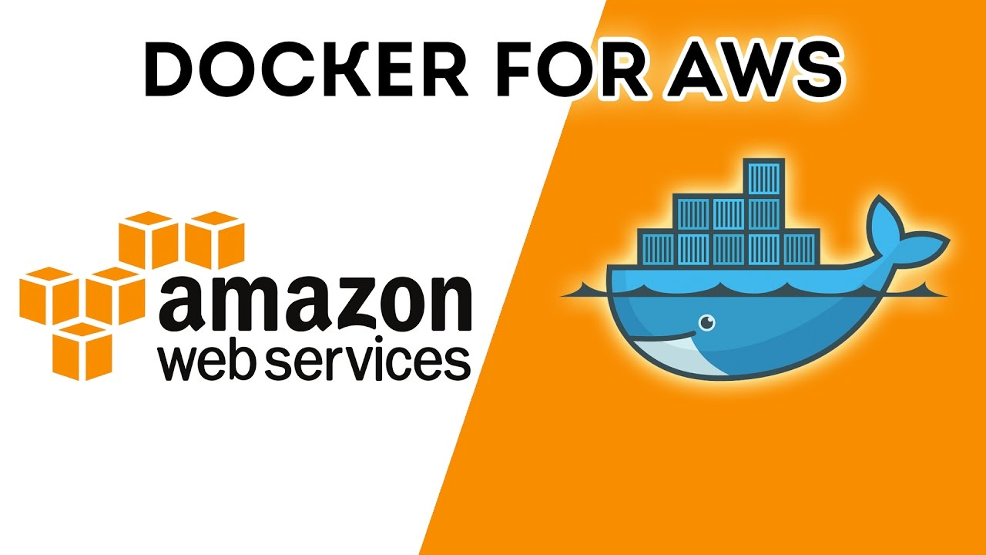

# **Introduction**

Docker is an open source software platform that allows to build, test, and deploy applications quickly.

Docker helps solve the problem for the teams working on different platforms by providing an isolated environment for the application so that it runs on all platforms alike.

Amazon Elastic Container Service (Amazon ECS) is the Amazon Web Service to run Docker applications on a scalable cluster.

Why deploy docker images on cloud specifically ECS? It gives these features right out of the box saving developers time and additionally it is fast, simple, cost-efficient and secure. Developers can focus on developing applications rather than worrying about managing configurations.

In this project I have developed a web service using spring boot and maven and docker hub for docker image. Alternatively, I have also created a repository on Amazon Elastic Container Registry (ECR). ECR is a fully-managed Docker container registry provided and fully managed by AWS. I have covered how to create a repository on ECR.

# **Service Implementation**

This project implements webservices using Maven build and Spring Boot framework for microservices.

Git repository link for the code: <https://github.com/jalpaashara/SpringDockerAWS>

The web service contains **two GET routes**:

* One that displays a collection of records (List all Breweries)
* One that displays a single record that corresponds to an ID (List a particular brewery)

Source Data: I have used a static JSON file as source for data.

Below screenshot shows the root directory listing of the spring boot application

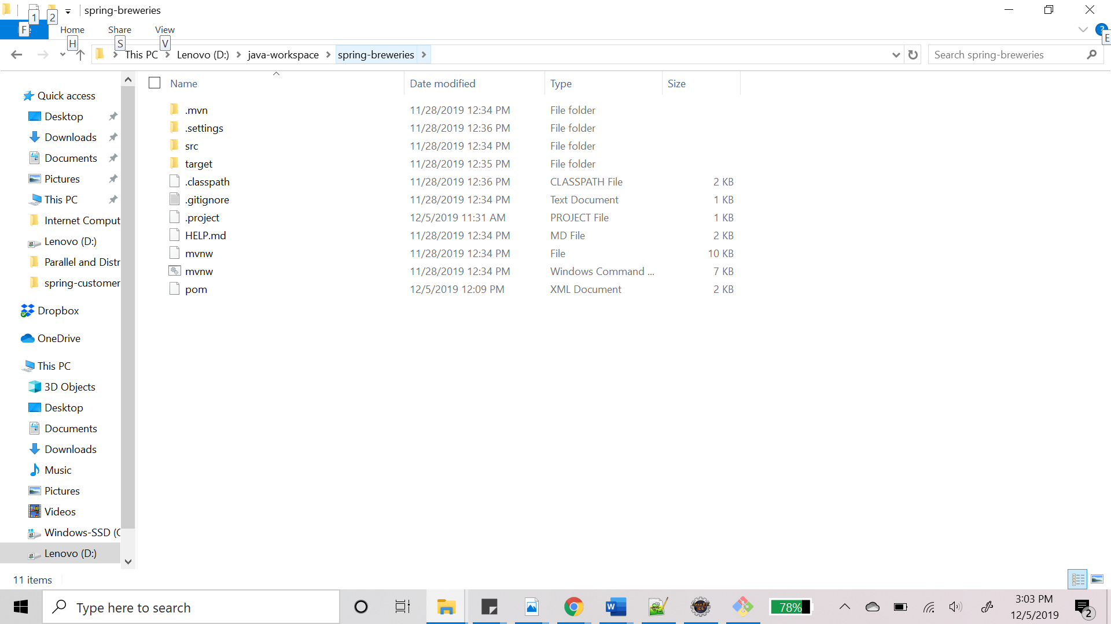

Below is the target folder before maven build is done.

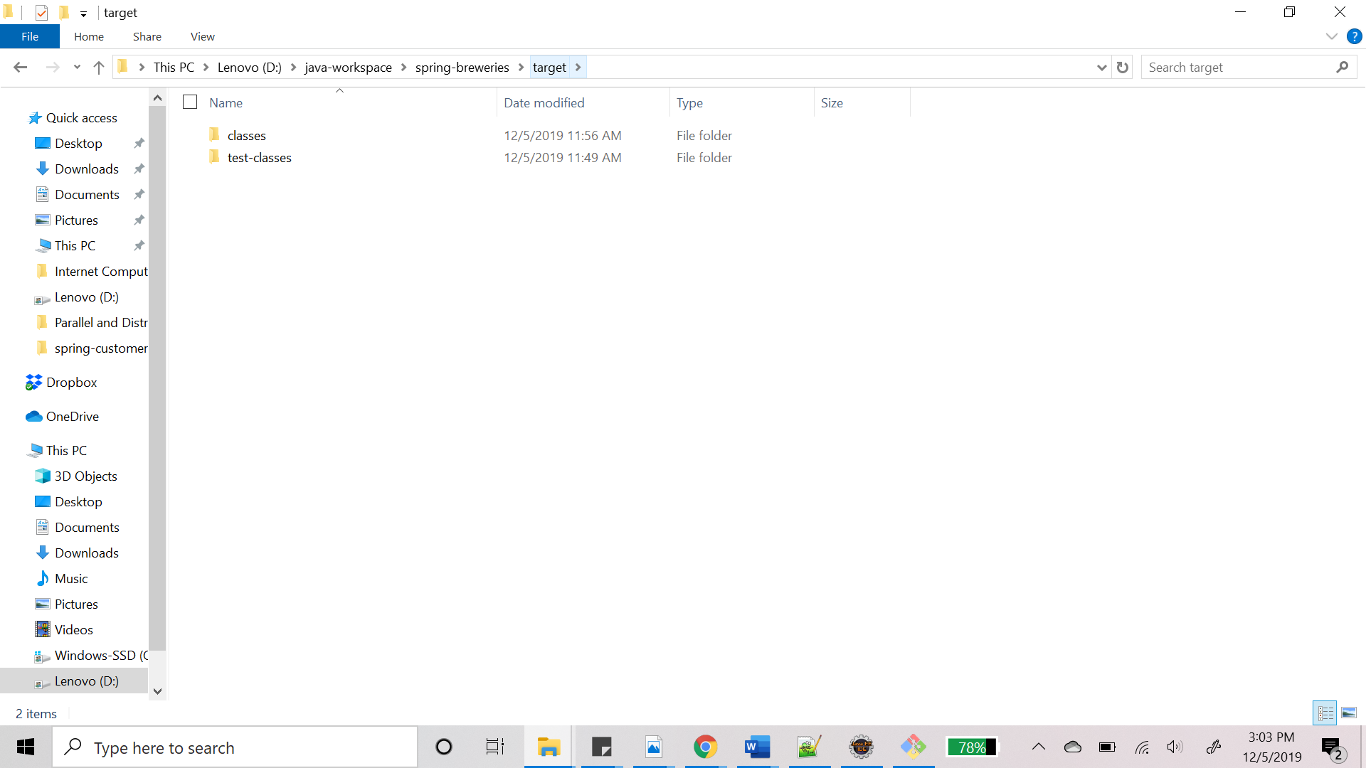

## Running “./mvnw package”.

This command does the job of compiling, verifying and building the project. It builds the jar file and places it in the target directory under the root project folder.

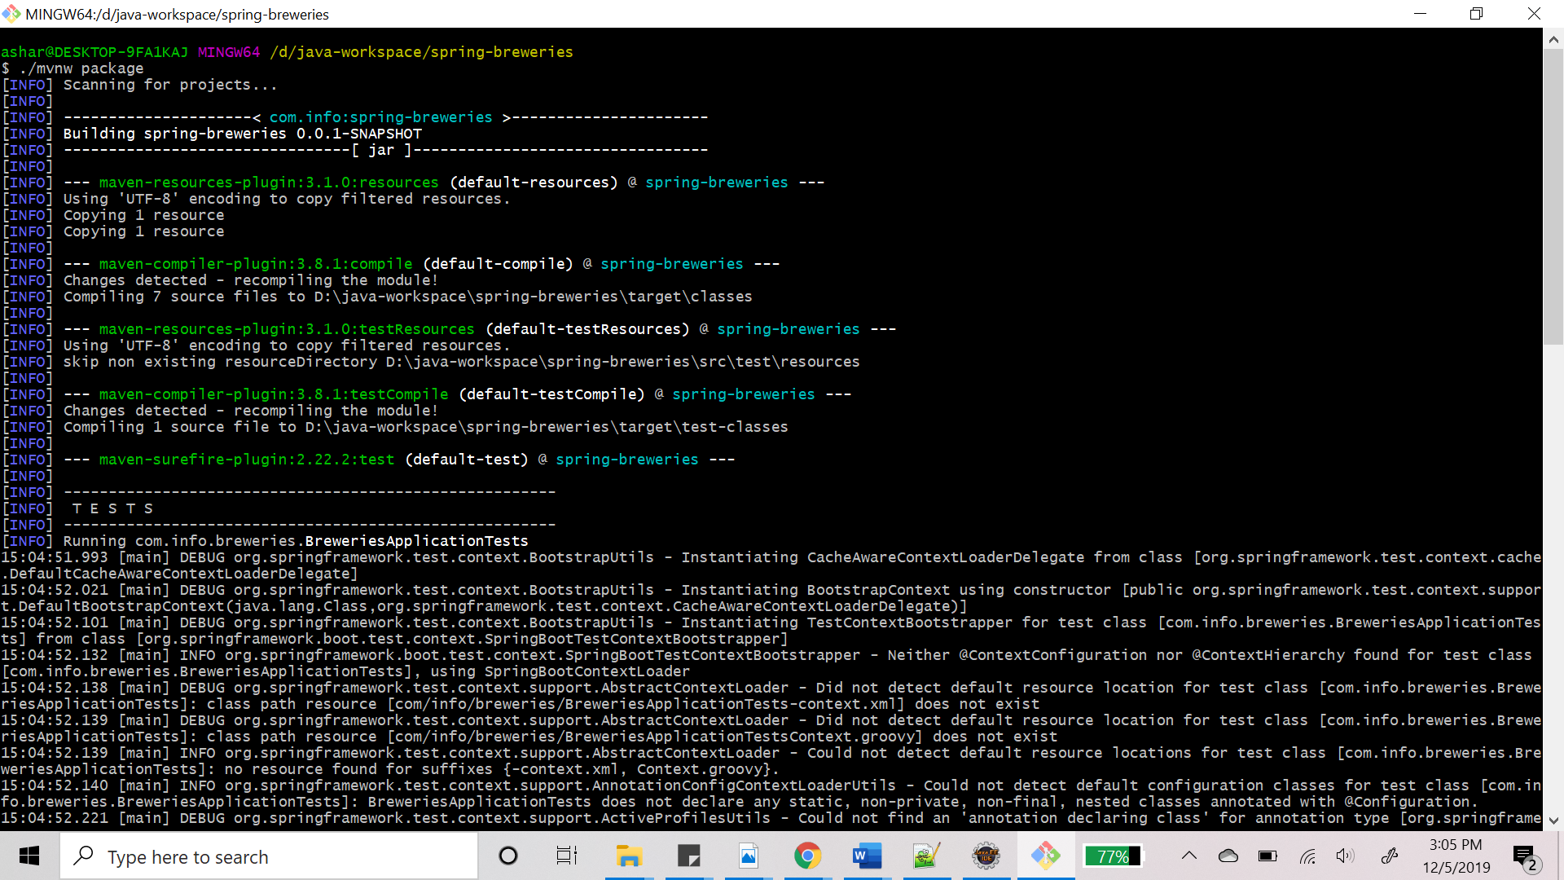

**Maven build success:**

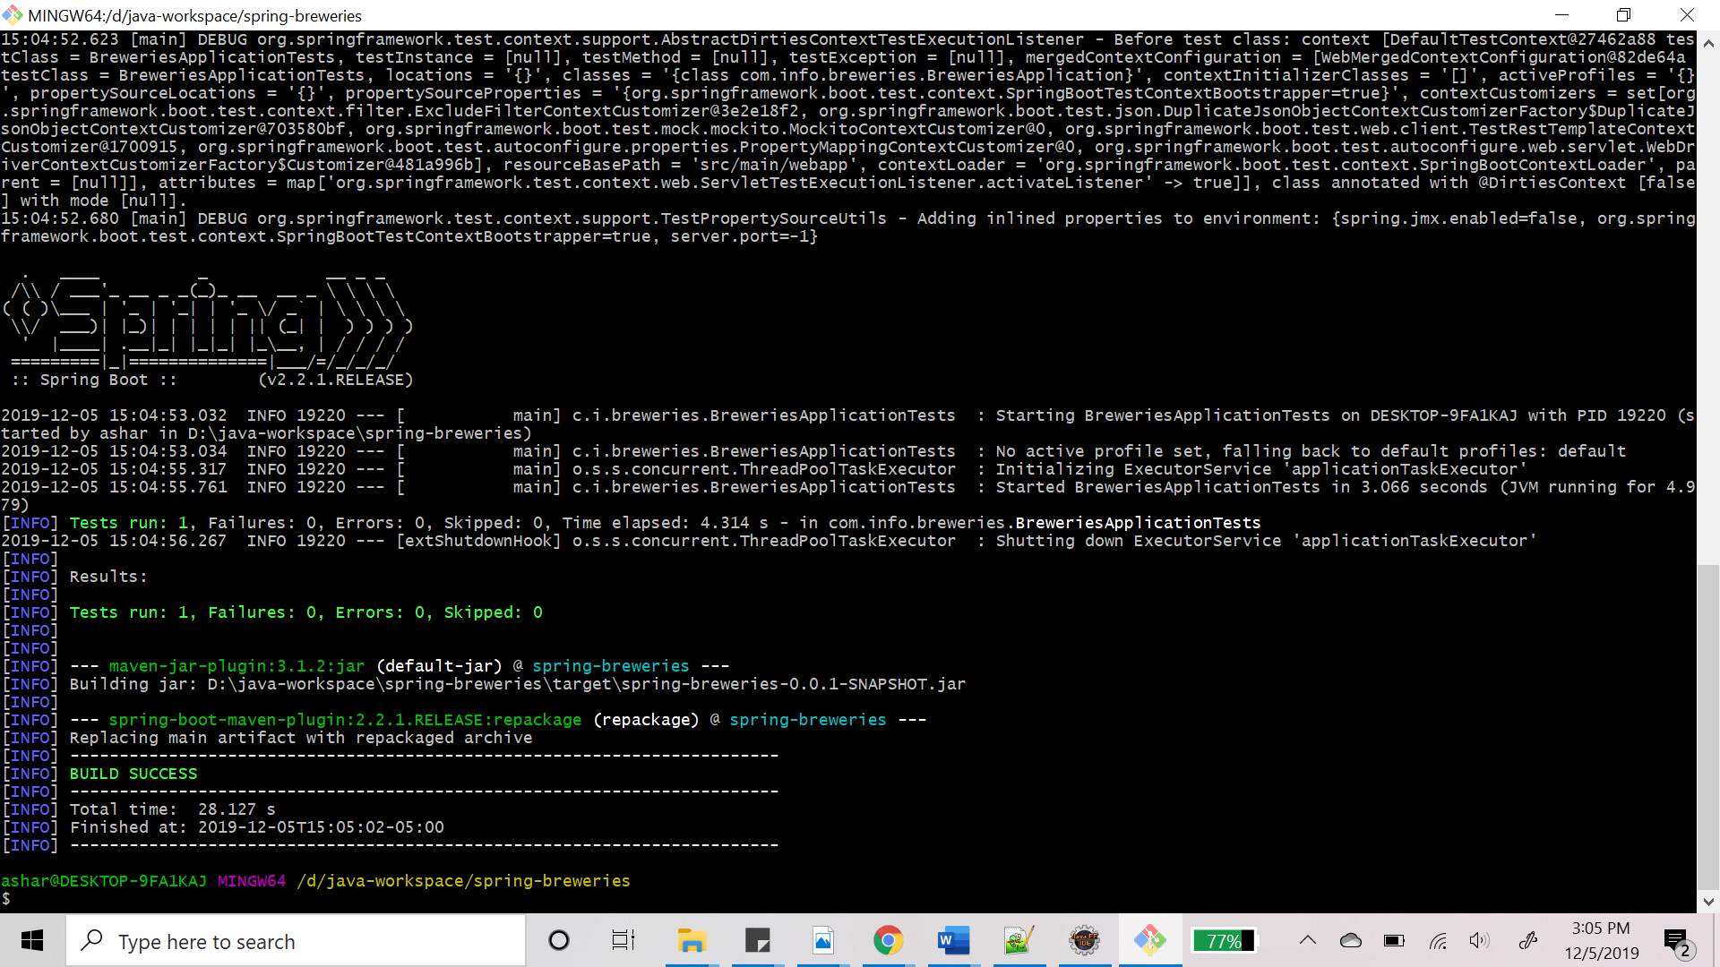

# **Containerizing the project:**

## Creating Dockerfile :

Docker has a simple "Dockerfile" file format that it uses to specify the layers of an image.  
Below is how I have created the Dockerfile:  
FROM openjdk:8-jdk-alpine  
VOLUME /tmp  
ARG DEPENDENCY=target/dependency  
COPY ${DEPENDENCY}/BOOT-INF/lib /app/lib  
COPY ${DEPENDENCY}/META-INF /app/META-INF  
COPY ${DEPENDENCY}/BOOT-INF/classes /app

ENTRYPOINT ["java","-cp","app:app/lib/*", "com.cust.order.SpringCustomerOrderApplication"]  
EXPOSE 8080

This Dockerfile has a DEPENDENCY parameter pointing to a directory.  
The command in the below screenshot will generate the following folders in the target/dependency folder:  
BOOT-INF/classes - with the application classes  
BOOT-INF/lib - with the dependency jars  
META-INF

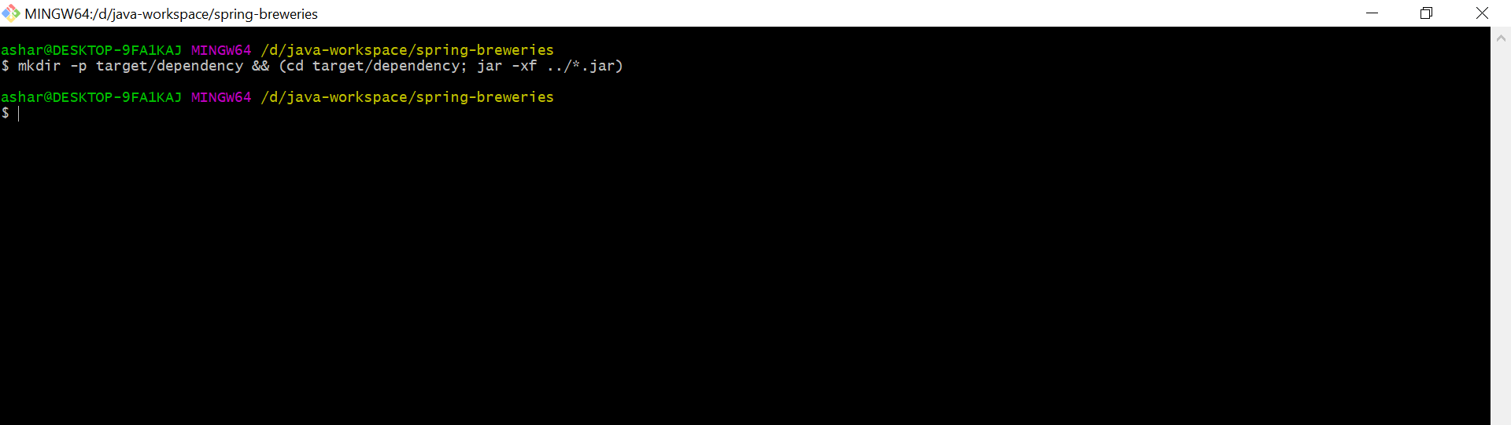

Dependency folder created:

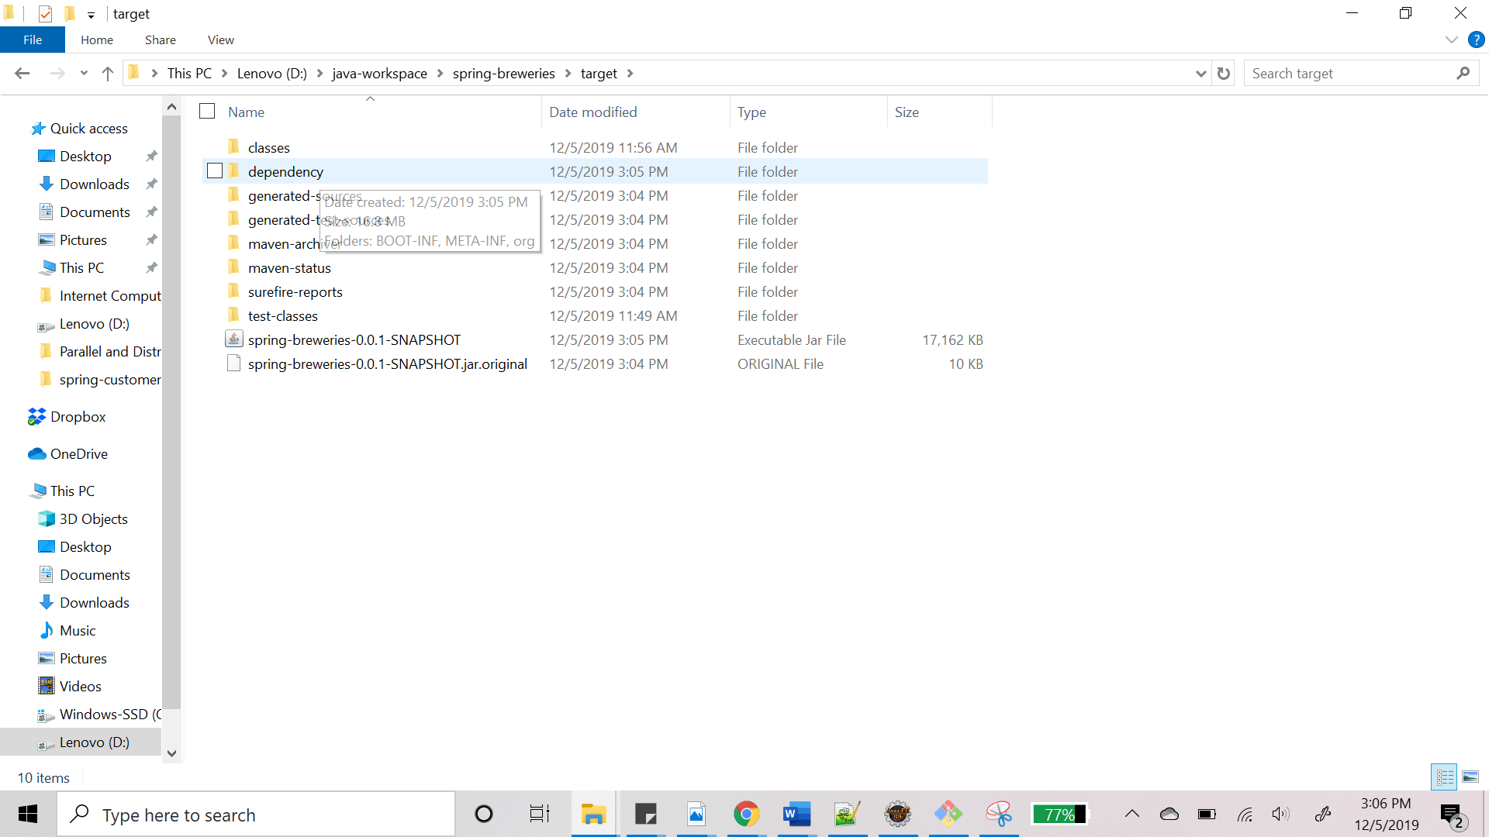

## **Building Docker Image**

Now all the setup needed to build the docker image is done. The screenshot below shows the build command (docker build -t jalpaashara/spring-breweries .) and the image successfully created.

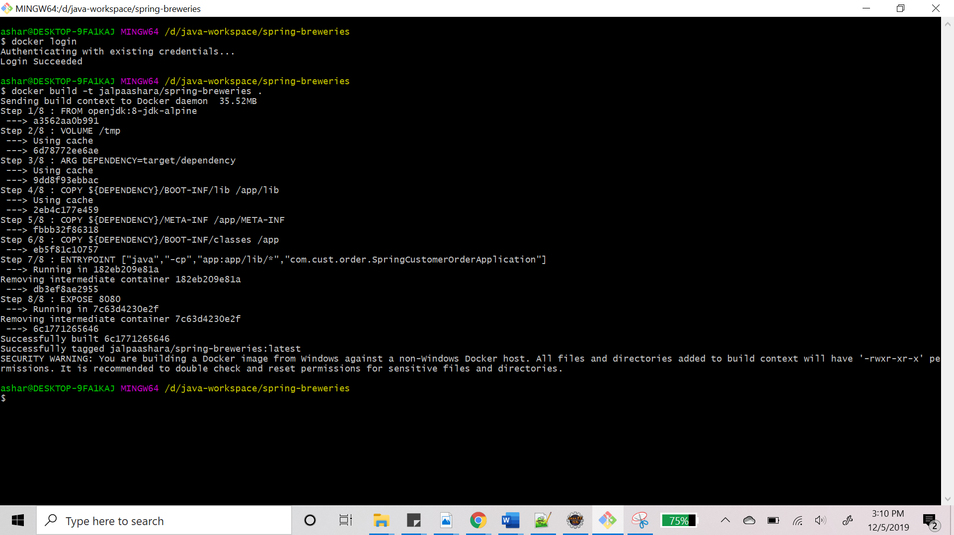

## **Docker image pushed to Docker Hub registry**

The screenshot below shows the docker image pushed to docker hub and from docker hub repository, the image can be run from anywhere.

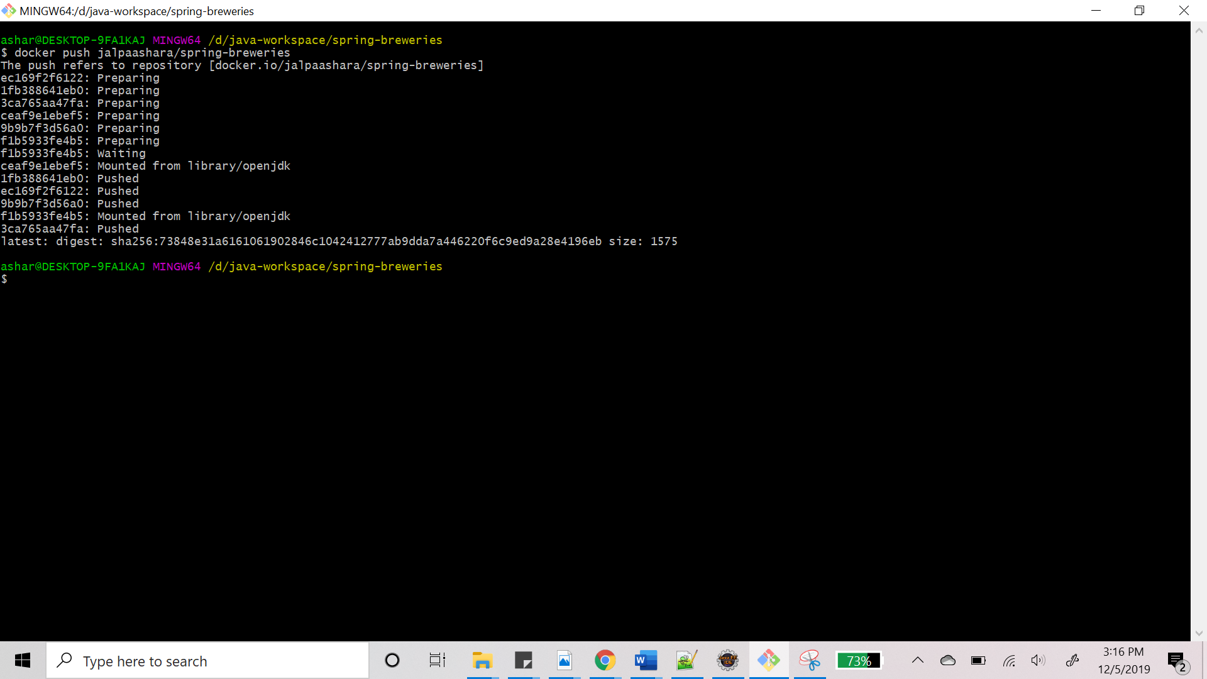

Repository available on docker hub

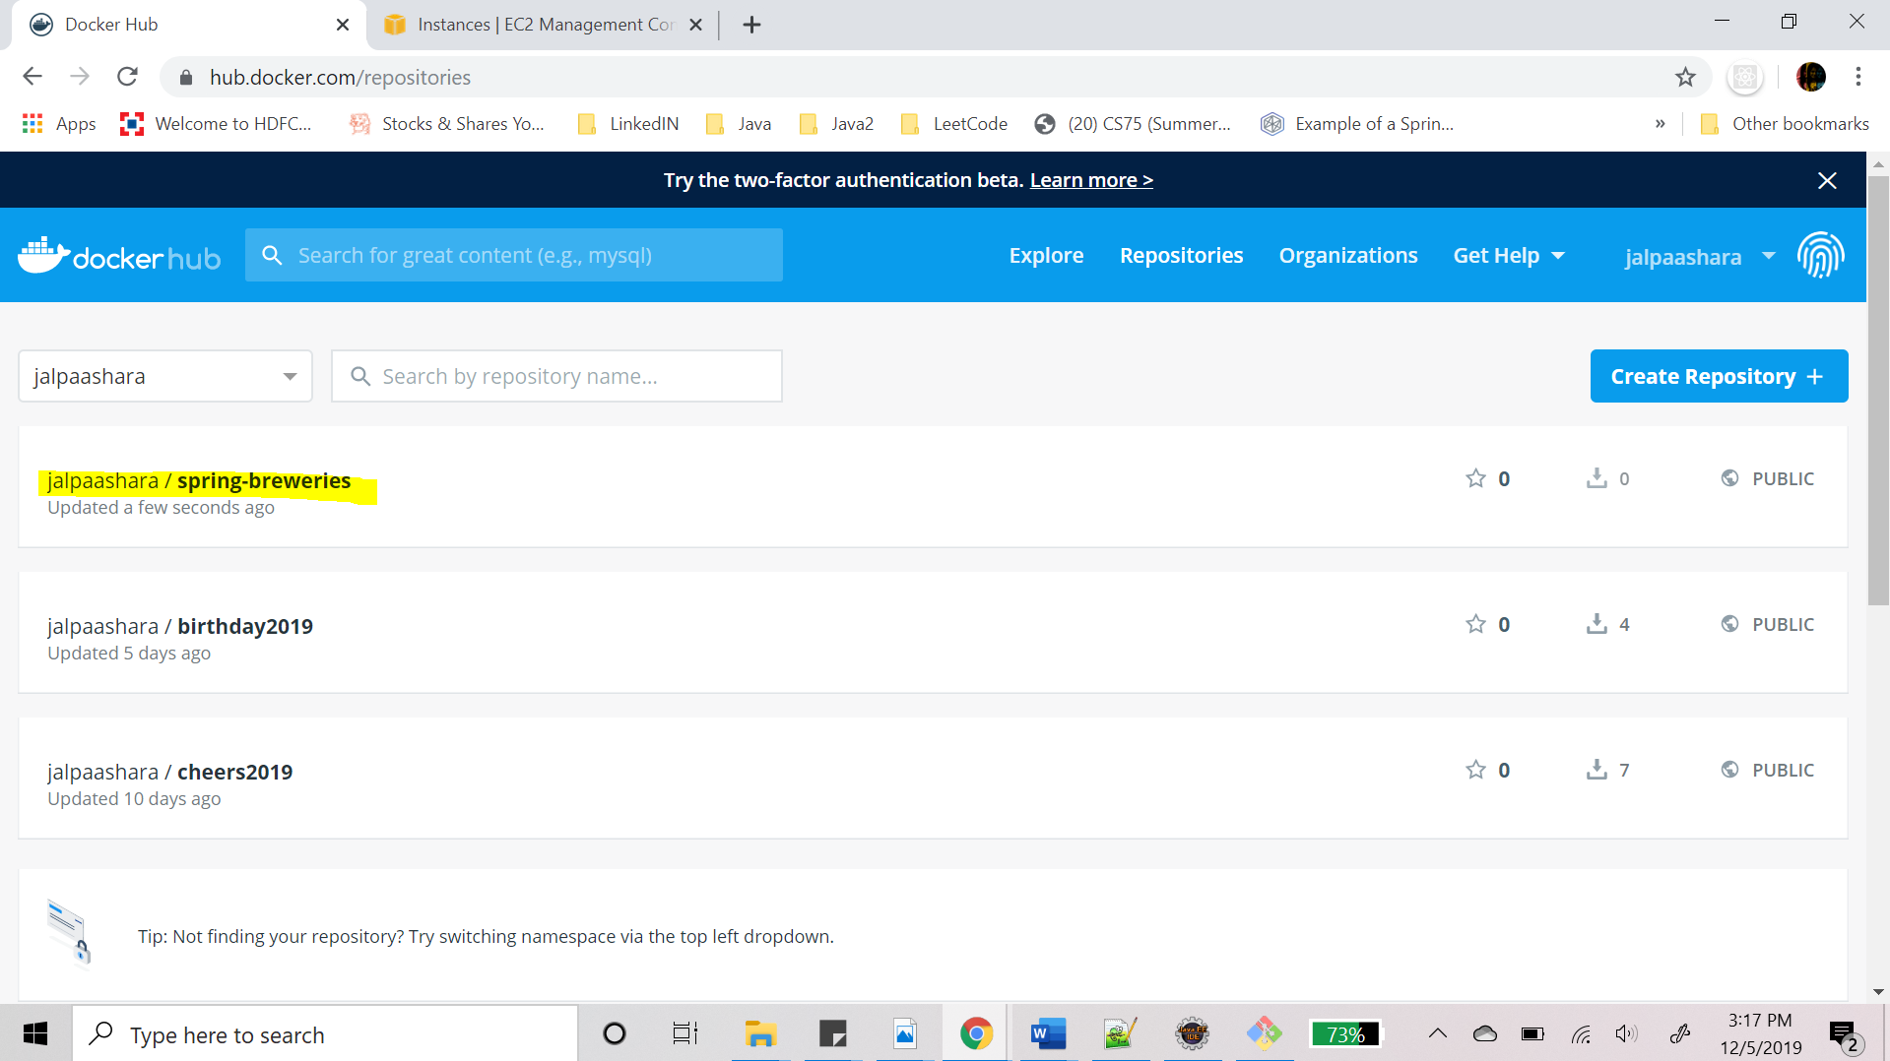

# **Docker Implementation on AWS**

AWS Elastic Container Service(ECS) is a Docker container orchestration service. It can run one or more Docker images, either as an auto-scaling capable "Service" or as an ad-hoc "Task". The services and tasks run on a "Cluster". AWS provides two options to run containers using AWS ECS.

1. Fargate – Runs tasks on the cluster
2. EC2 - Runs Container Instances on the cluster

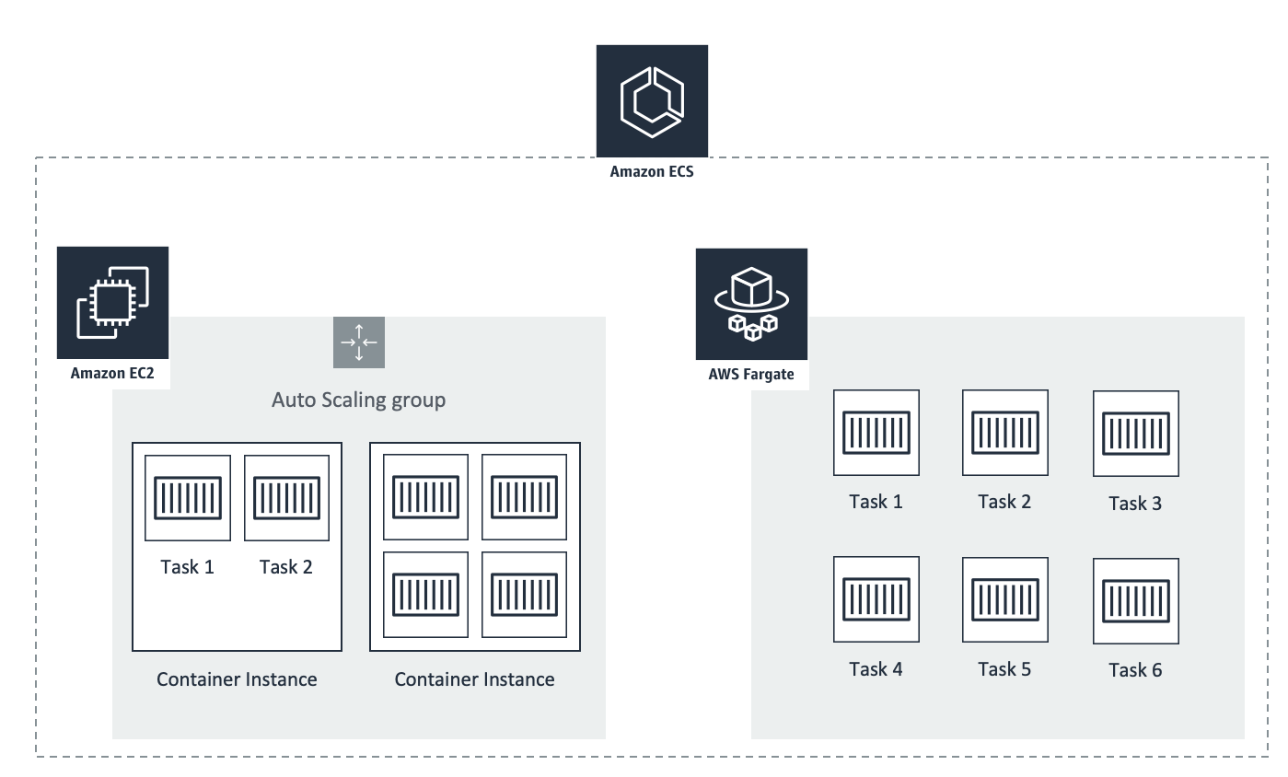

## **Using Fargate**

### **Overview**

Another way to host a docker is on AWS is using AWS ECS on a Fargate Cluster.

The advantage of using AWS Fargate over EC2 is that it provides a serverless compute engine for containers making it easy to focus on building applications rather than managing infrastructure.

Fargate allows to define the amount of CPU and memory the Task or Service requires to operate, meaning that just pay for the CPU and memory time per task that runs on the cluster, and improves security through application isolation by design.

Steps and screenshots below show how I have used AWS Fargate cluster on AWS ECS to run a docker image container.

### **Create a new Task Definitions**

1. Go to Services -> Compute -> ECS
2. The page below will open up and click on Create new Task definition.

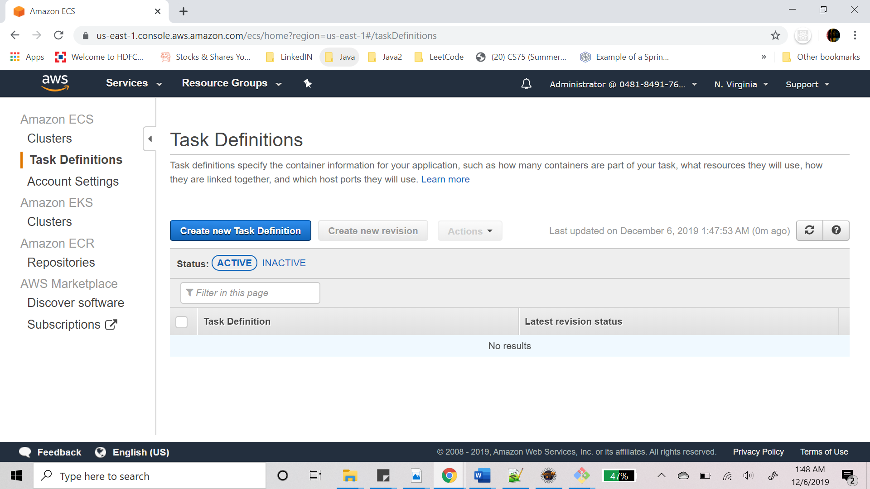

1. Select FARGATE launch type

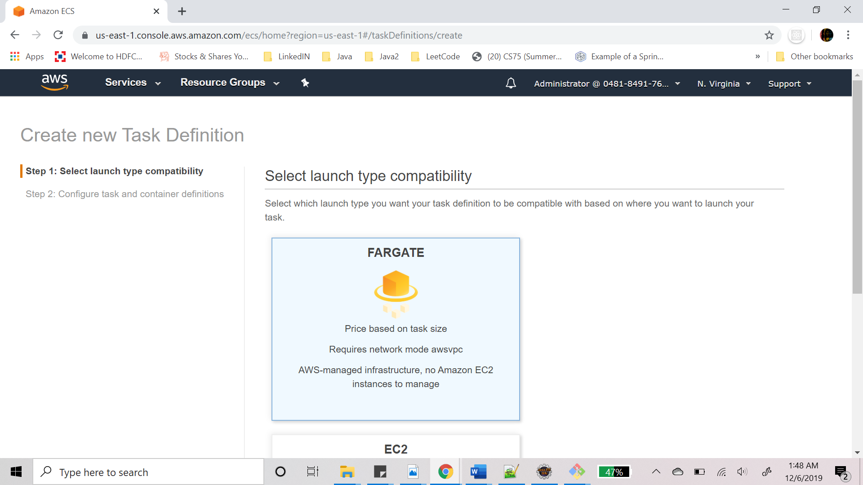

1. Configure Tasks and container definitions.
   1. Provide task definition name
   2. Task role -> none
   3. Everything else keep as it is

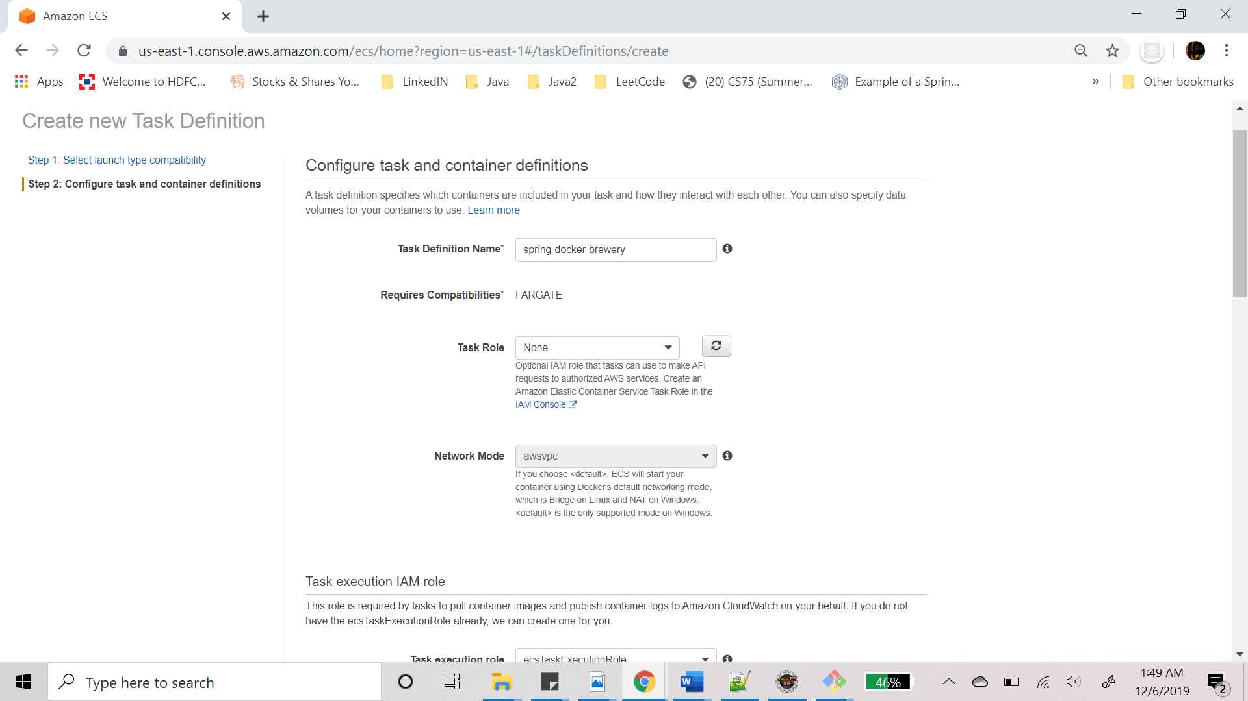

1. Add task size

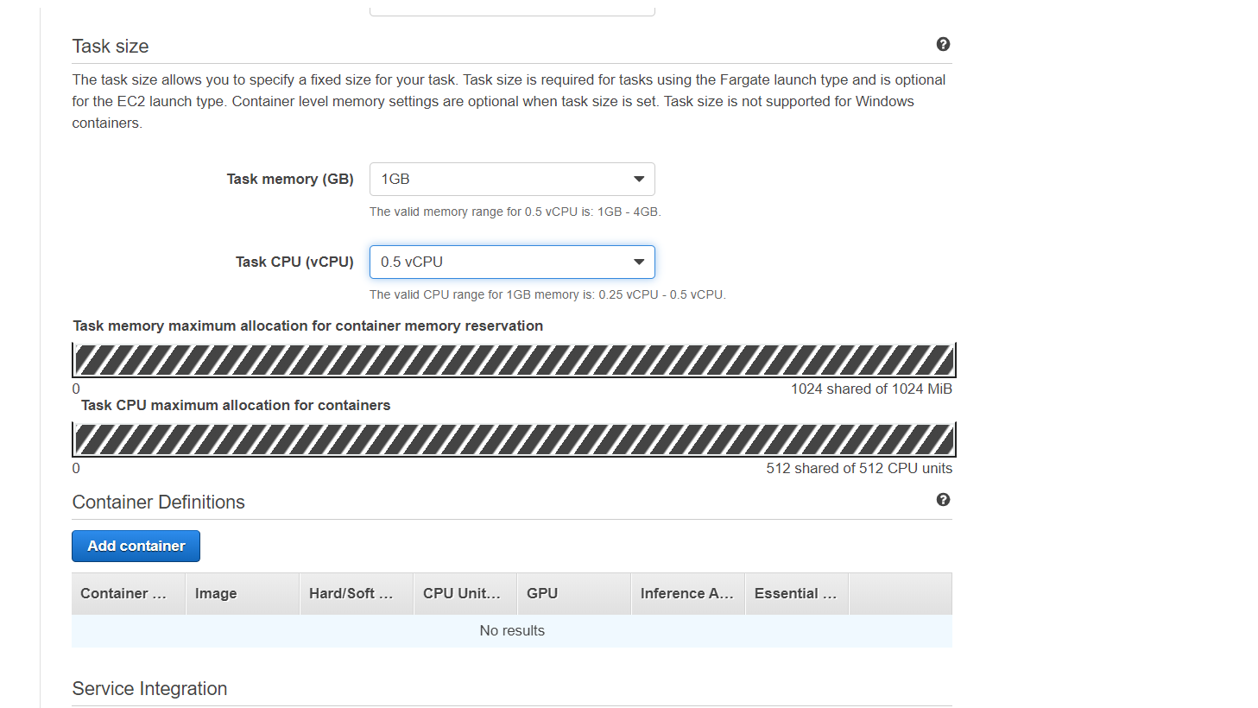

1. Add container:
   1. Provide container name
   2. Provide image : docker.io/dockerhubimage
   3. Provide memory limit
   4. Provide port mappings
   5. Click on Add
   6. The control goes back to the create class definition page, there click on Create

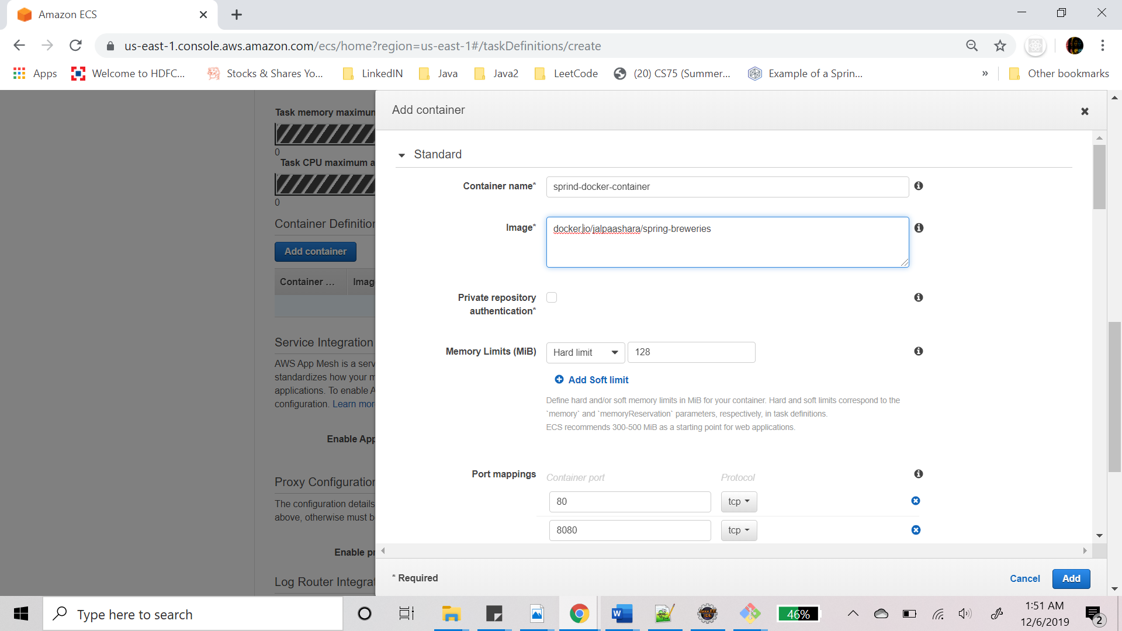

1. Task definition is now created.

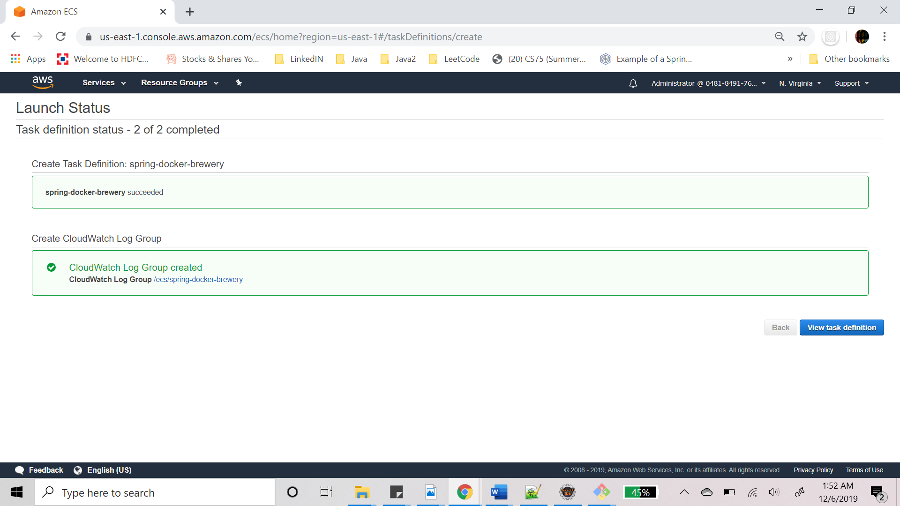

### **Create Cluster**

A cluster is required to run the task that we just created. So let’s go ahead and create a cluster.

1. Click on create cluster and the below page will open.
2. Select cluster template as “Networking only”
3. Click on Next Step

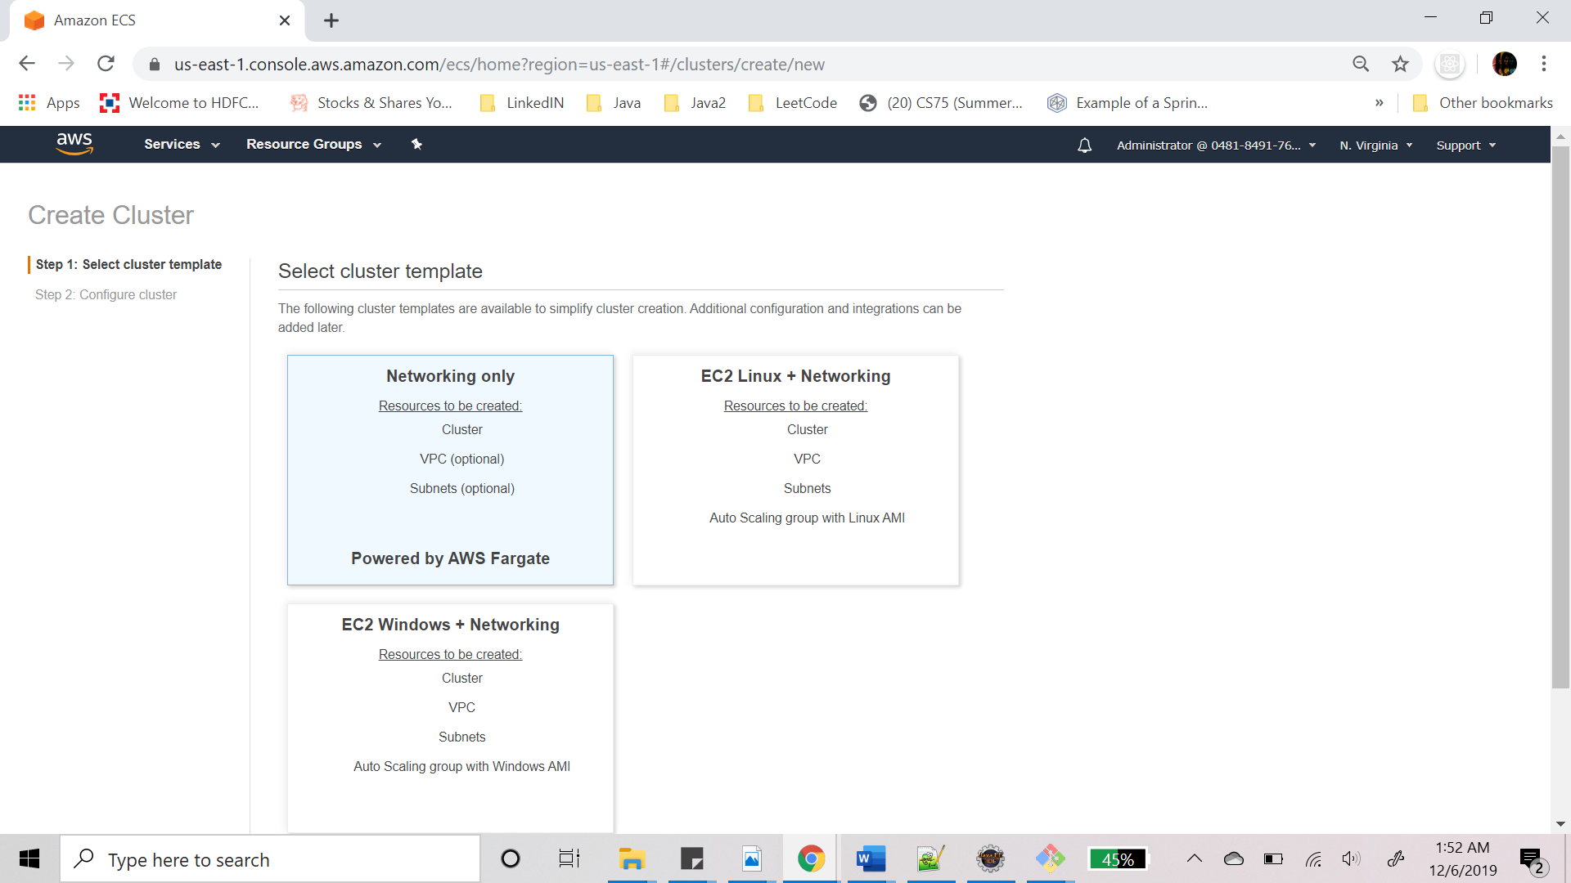

1. Next step is to Configure cluster:
   1. Provide cluster name.
   2. Click on create

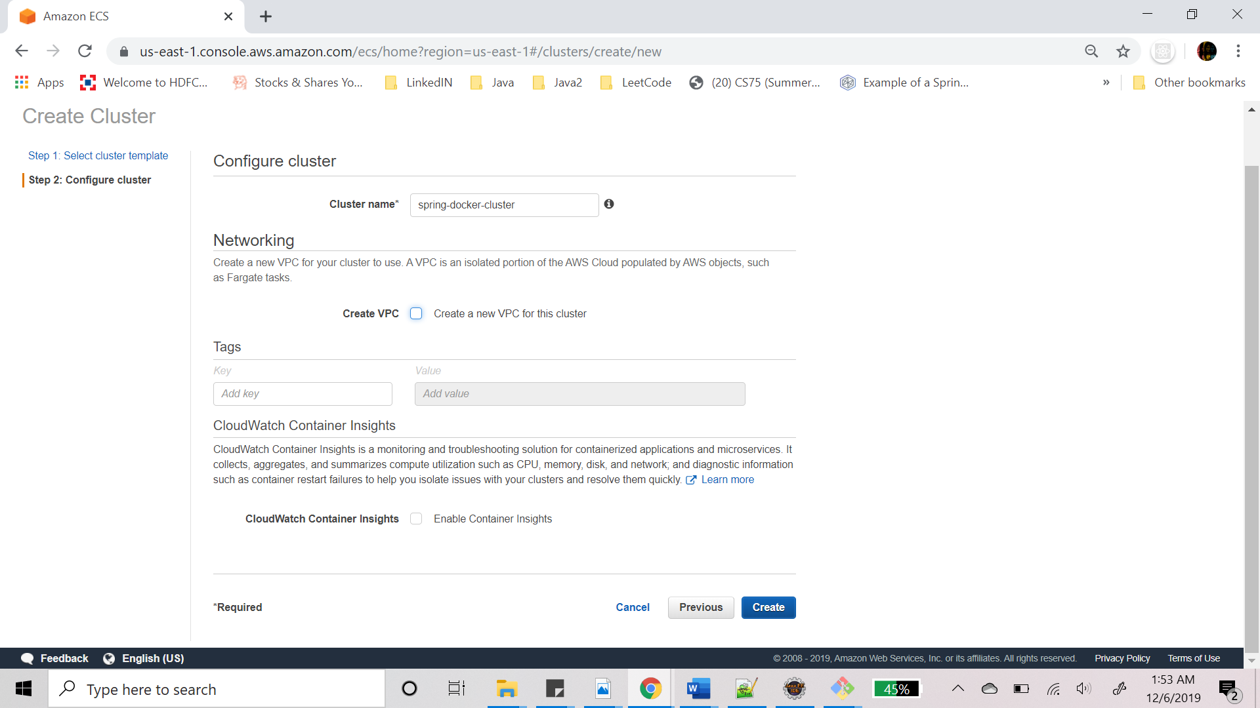

1. Cluster is created.

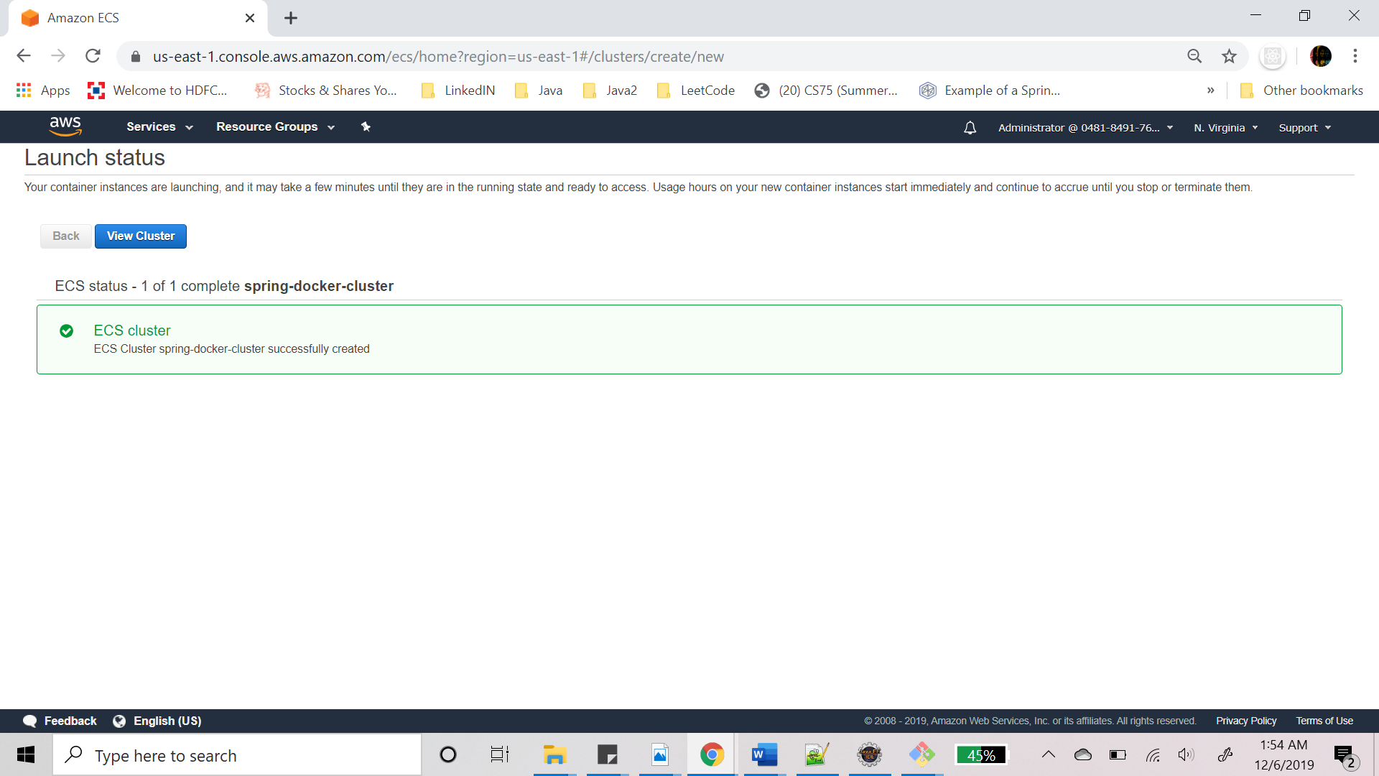

### **Run Task on the Cluster**

It’s time to run the task definition on the cluster. To do that go inside the cluster that was just created or simply click on view Cluster on the screen above.

1. Go to Tasks tab and click on Run new task, screen below will open.
2. Select Launch type as Fargate
3. Provide task definition from the drop down
4. Cluster will be auto selected, if not select the cluster that was created previously from drop down.
5. Select cluster VPC from dropdown
6. Select subnet

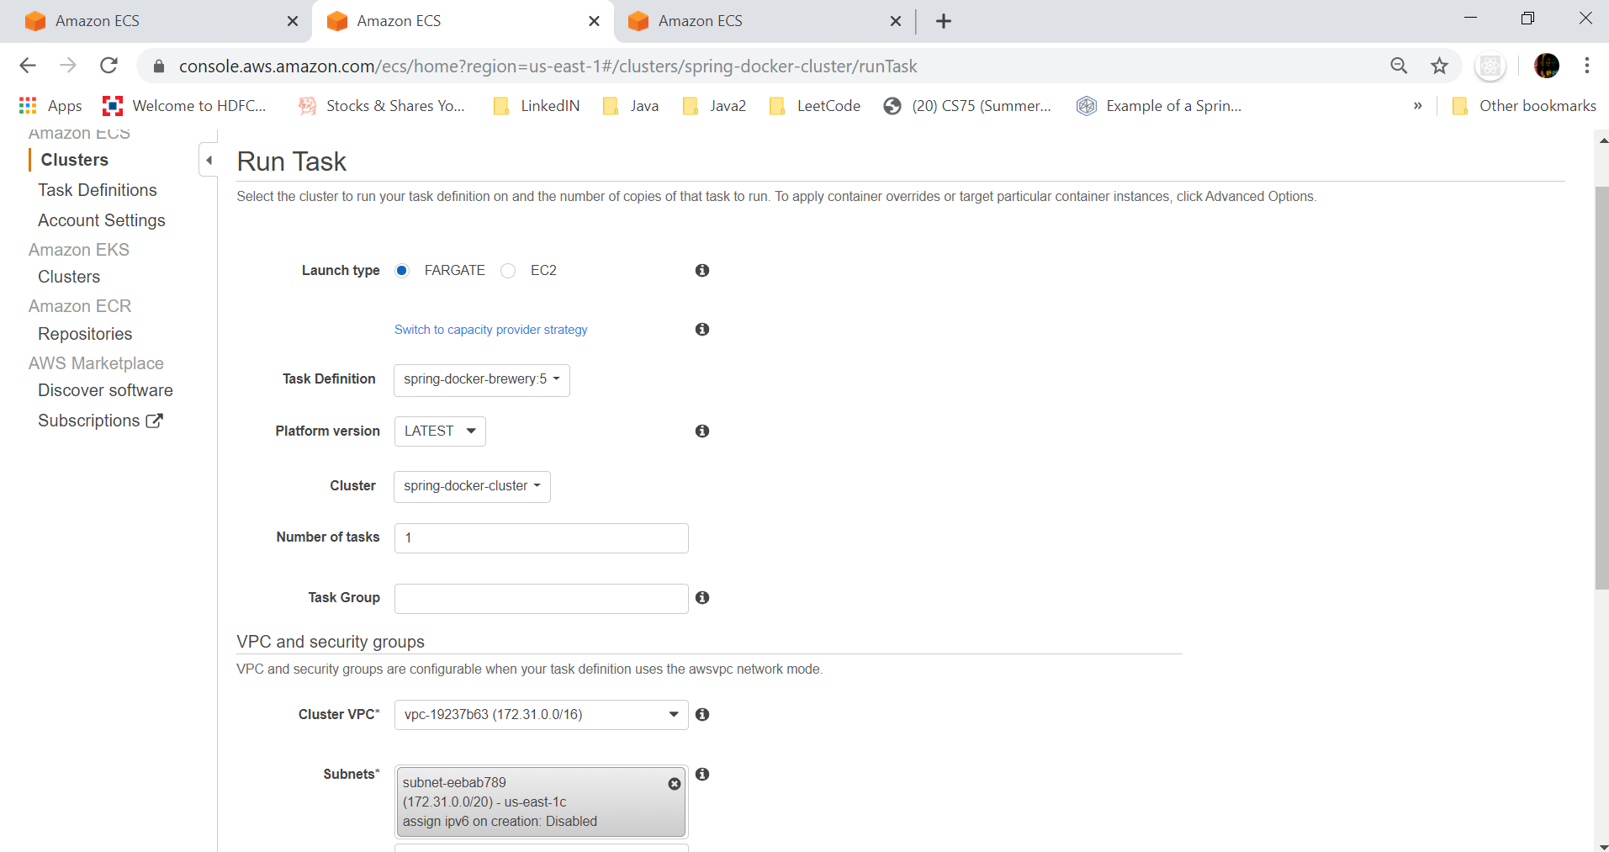

1. Click on Edit for Security groups
2. Select create new security group if you don’t have an existing group to allow all traffic and all tcp connections.
3. If creating new security group add rules to allow all tcp and all traffic
4. Click on save

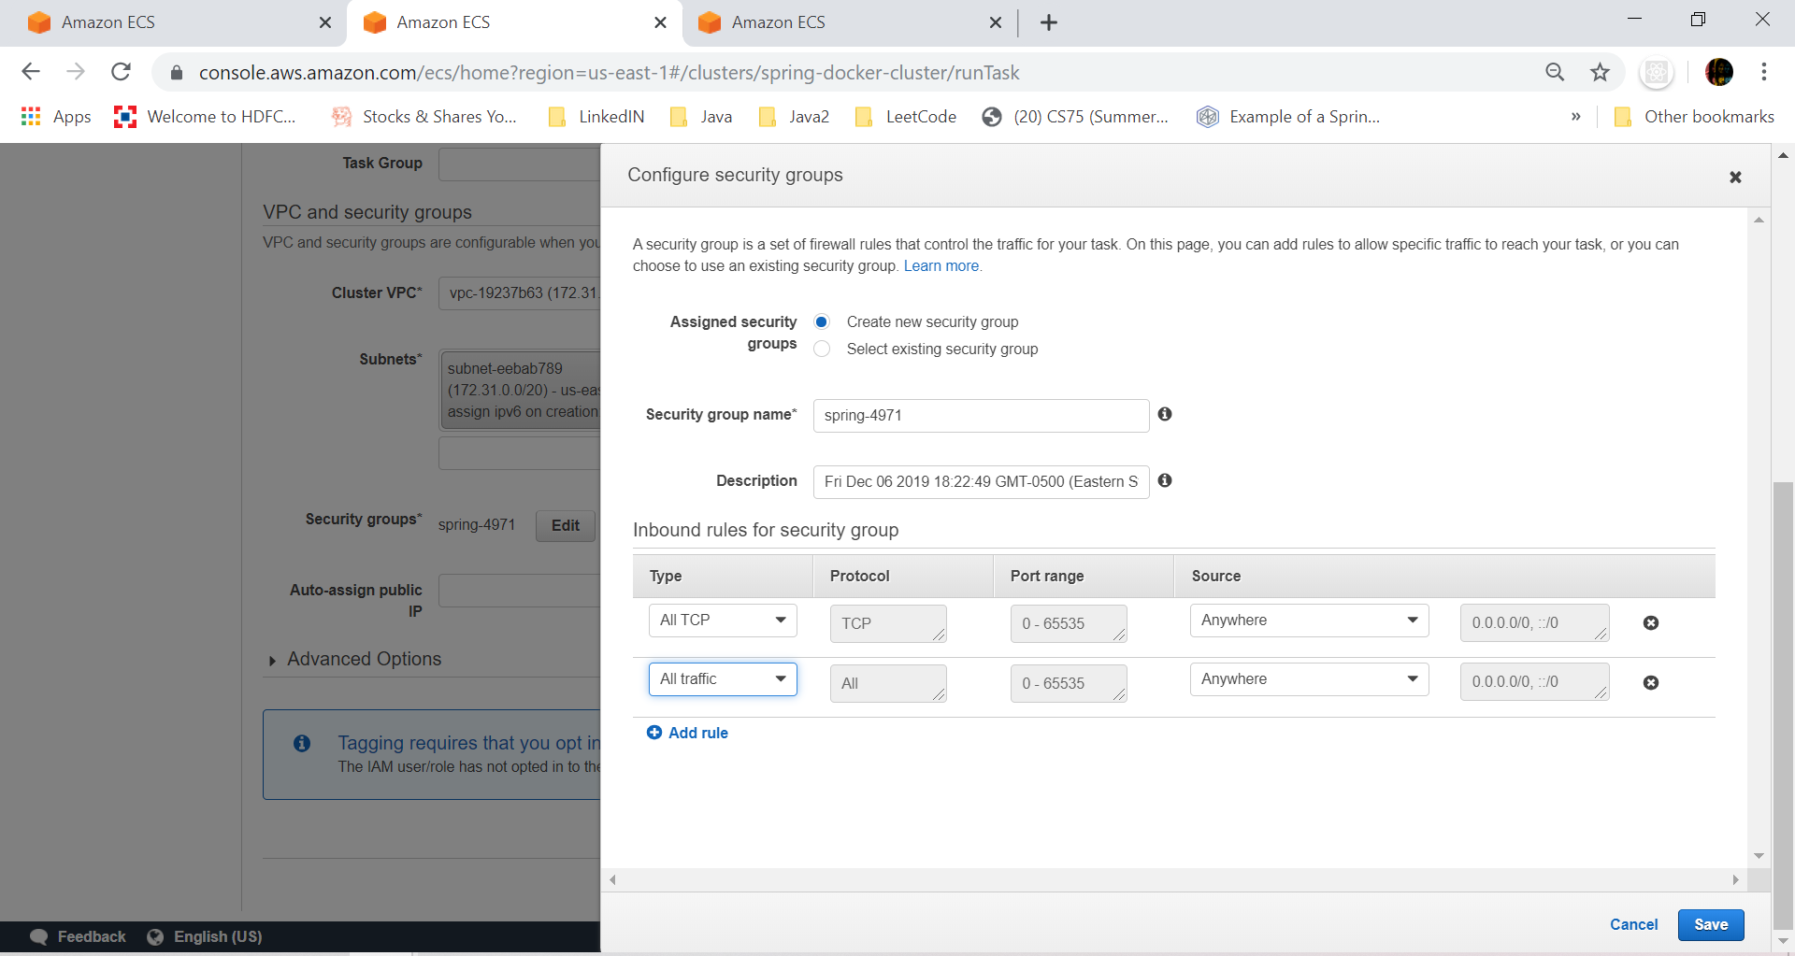

1. Click on Run Task

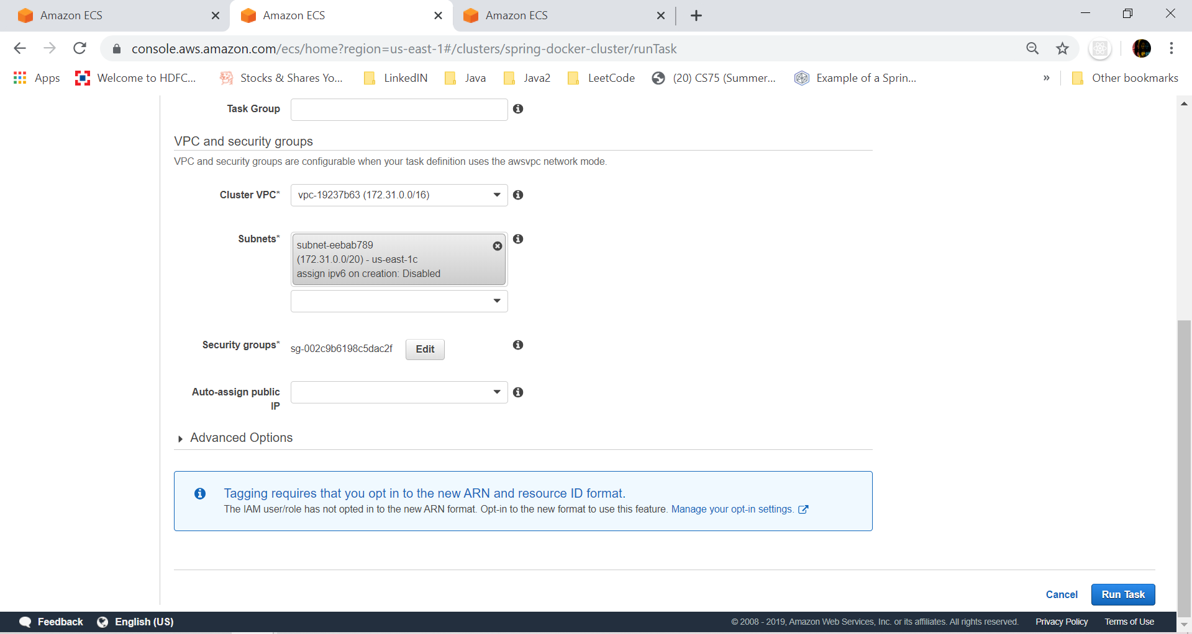

1. You can now see a task in the Tasks tab
2. Task in provisioning state, this could mean that the task is trying to pull the docker image from docker hub repository.

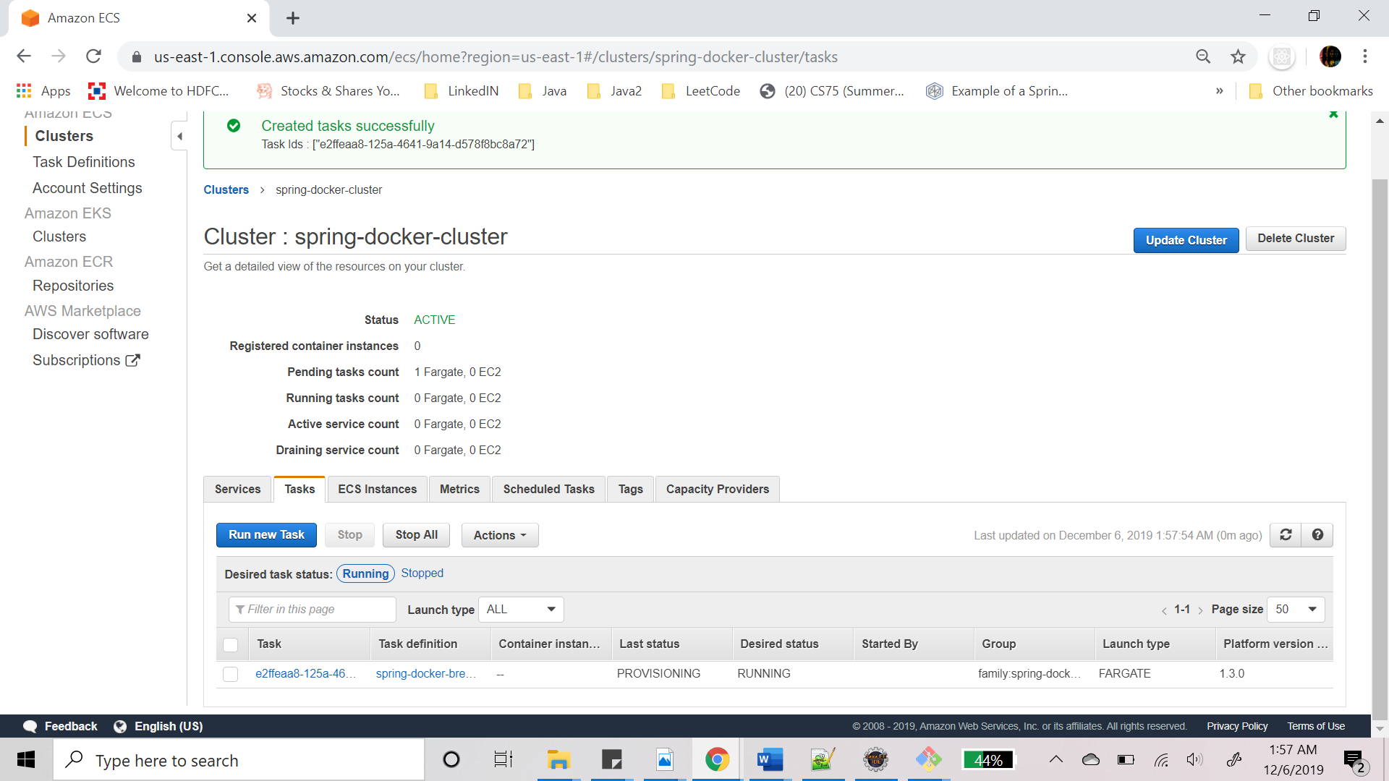

1. Click on the Task and you can now see the task is running.

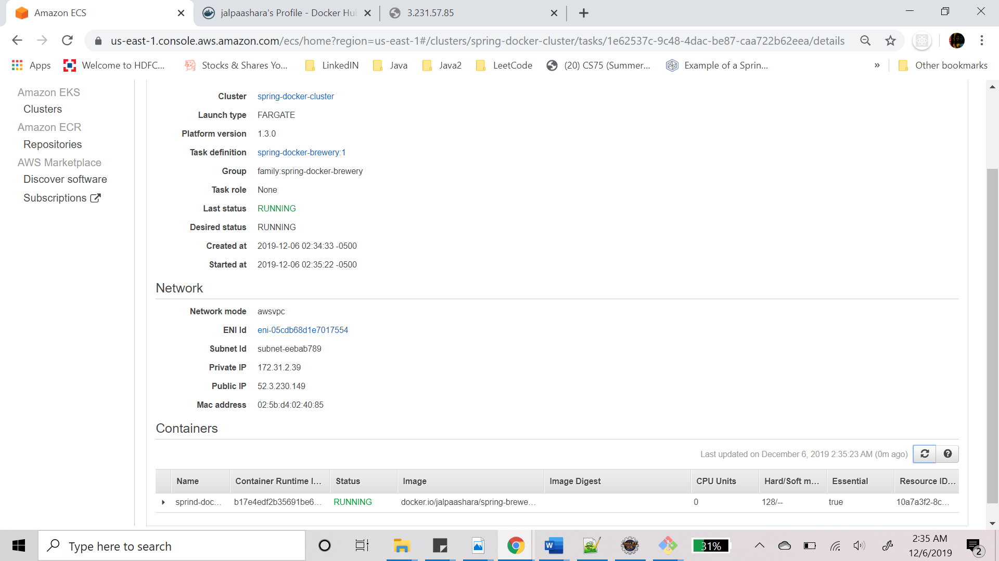

1. Task logs shows Spring Boot application “BreweriesApplication” has started

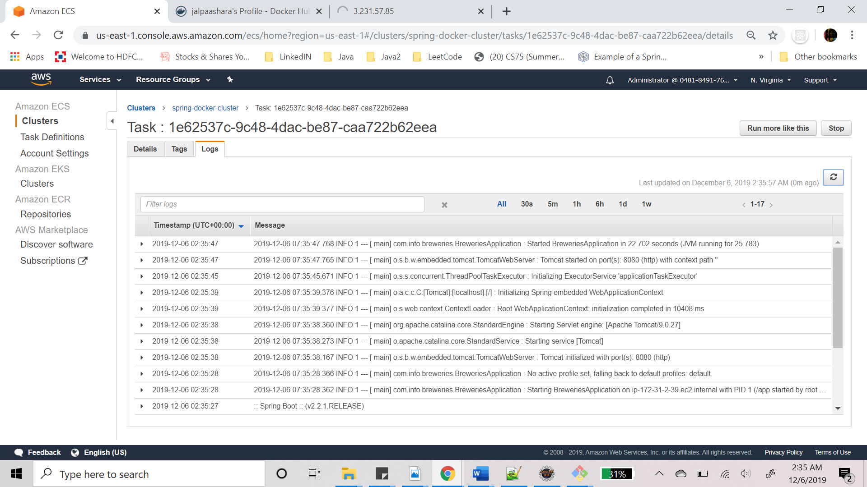

1. Go to a browser and provide the public_IP:8080 and you can see the JSON output.
2. <http://54.167.124.113:8080/>

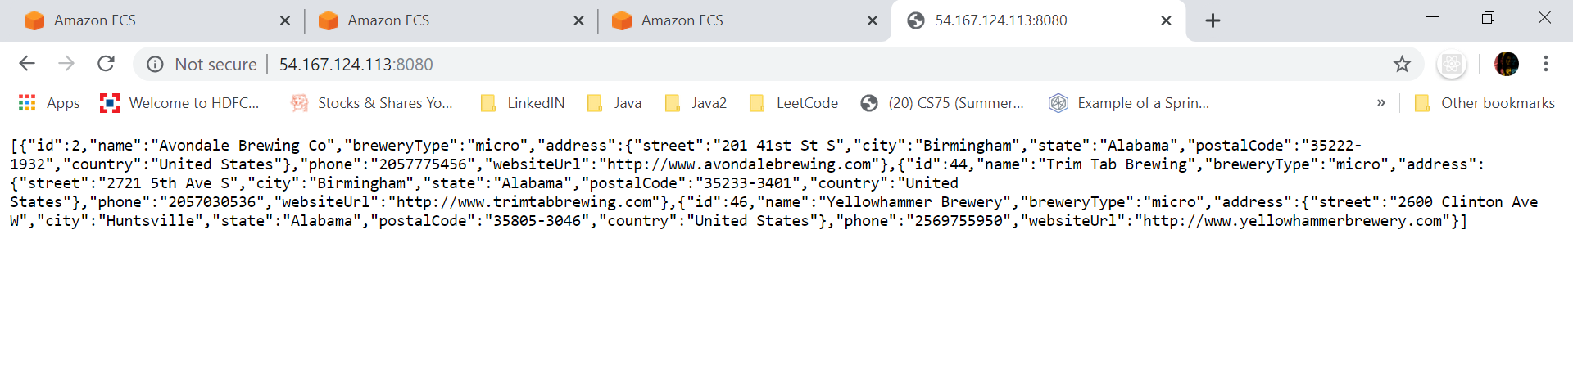

1. Get route for get brewery by id: <http://54.167.124.113:8080/46>

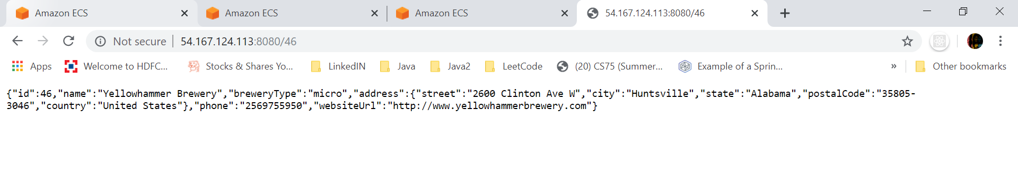

## **Using EC2 Instance:**

### **Overview**

Amazon Elastic Compute Cloud (EC2) allows to launch individual instances which can be used for pretty much anything. AWS calls virtual machines 'instances'.

EC2 provides complete control of computing resources, it allows users to select a configuration of memory, CPU, instance storage, and the boot partition size that is optimal for choice of operating system and application.

We can use EC2 with ECS to get more control over the server on which the container would be running.

In order to deploy an image on ECS using EC2, we follow similar steps like we did when using Fargate. The difference would be mainly while creating the cluster where we need to attach an EC2 instance to the cluster.

### **Creating new Task Definition**

1. Go to Services -> Compute -> ECS
2. The page below will open up and click on Create new Task definition.
3. Select EC2 launch type

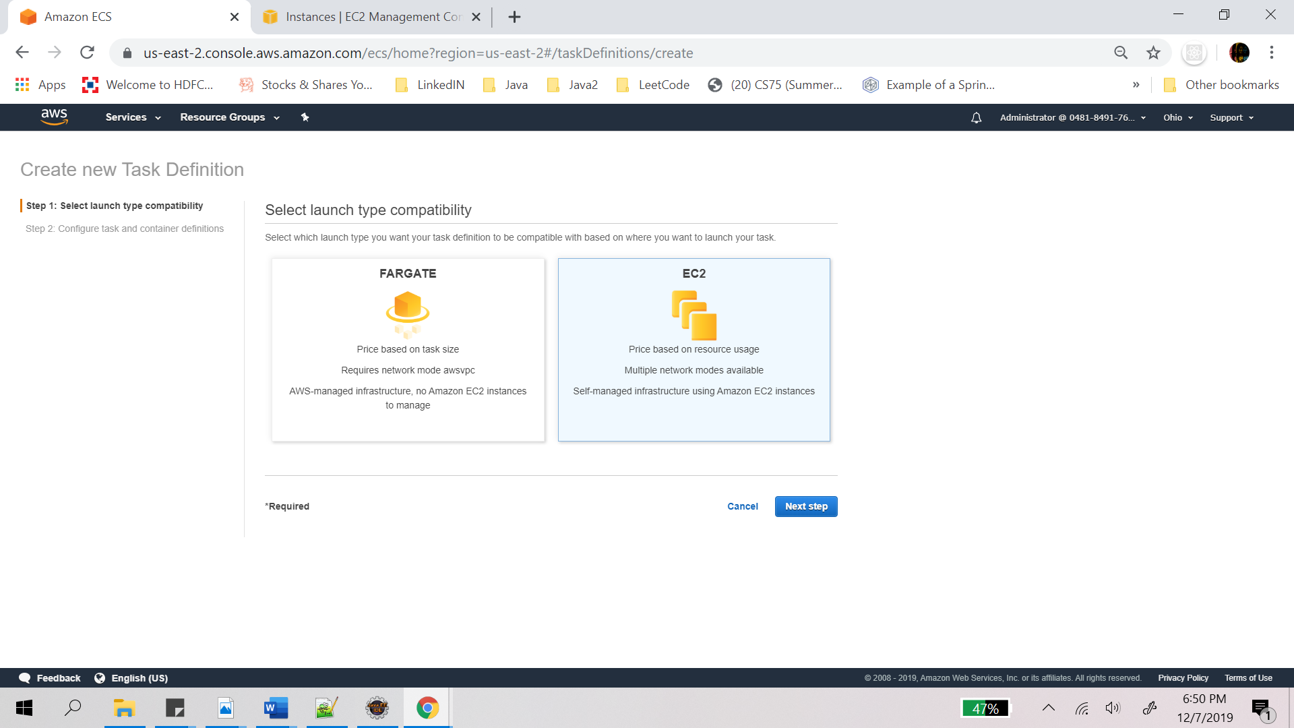

1. Configure Tasks and container definitions.
   1. Provide task definition name
   2. Task role -> none
   3. Everything else keep as it is
   4. Add task size

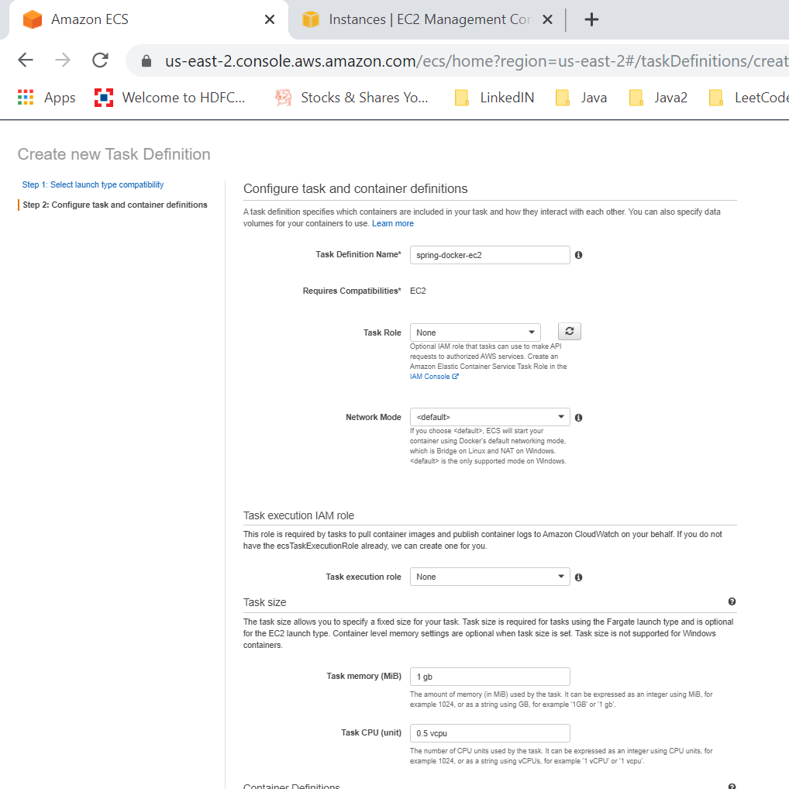

1. Add container:
   1. Provide container name
   2. Provide image : docker.io/dockerhubimage
   3. Provide memory limit
   4. Provide port mappings
   5. Click on Add
   6. The control goes back to the create class definition page, there click on Create

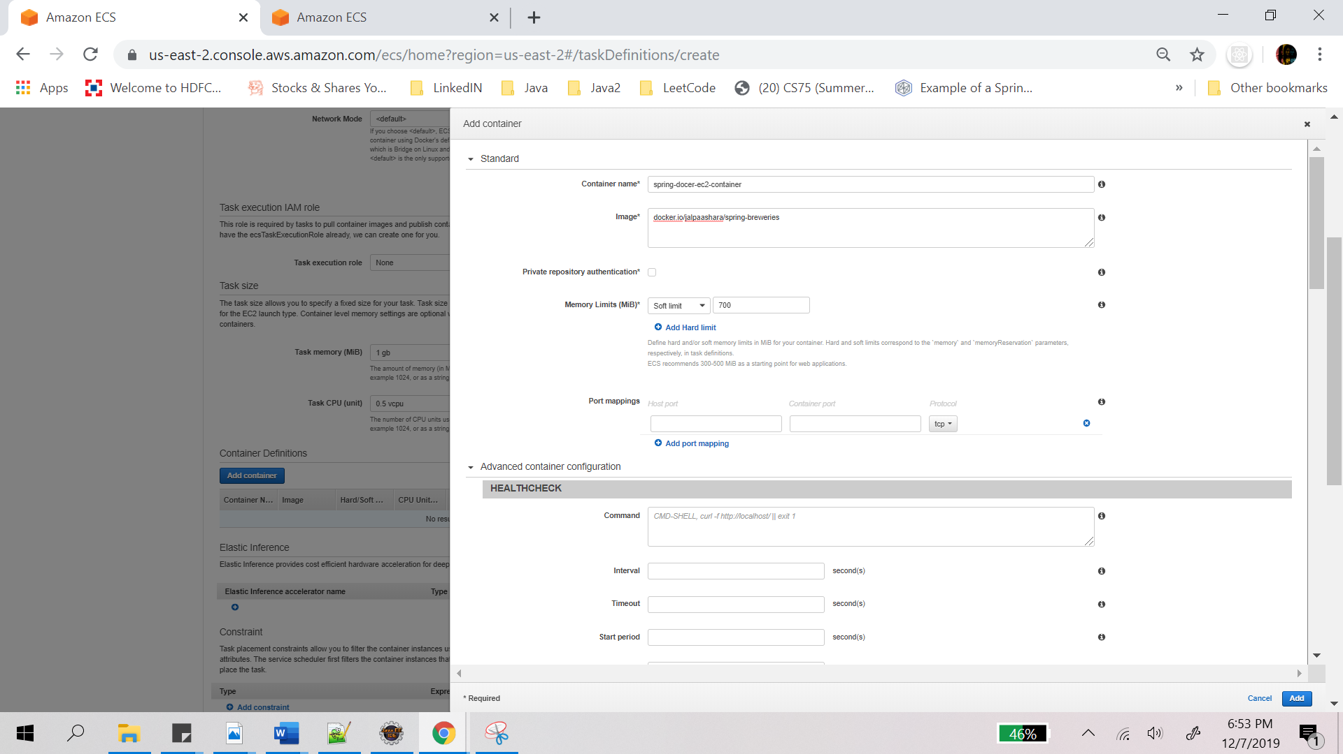

1. Task definition is now created.

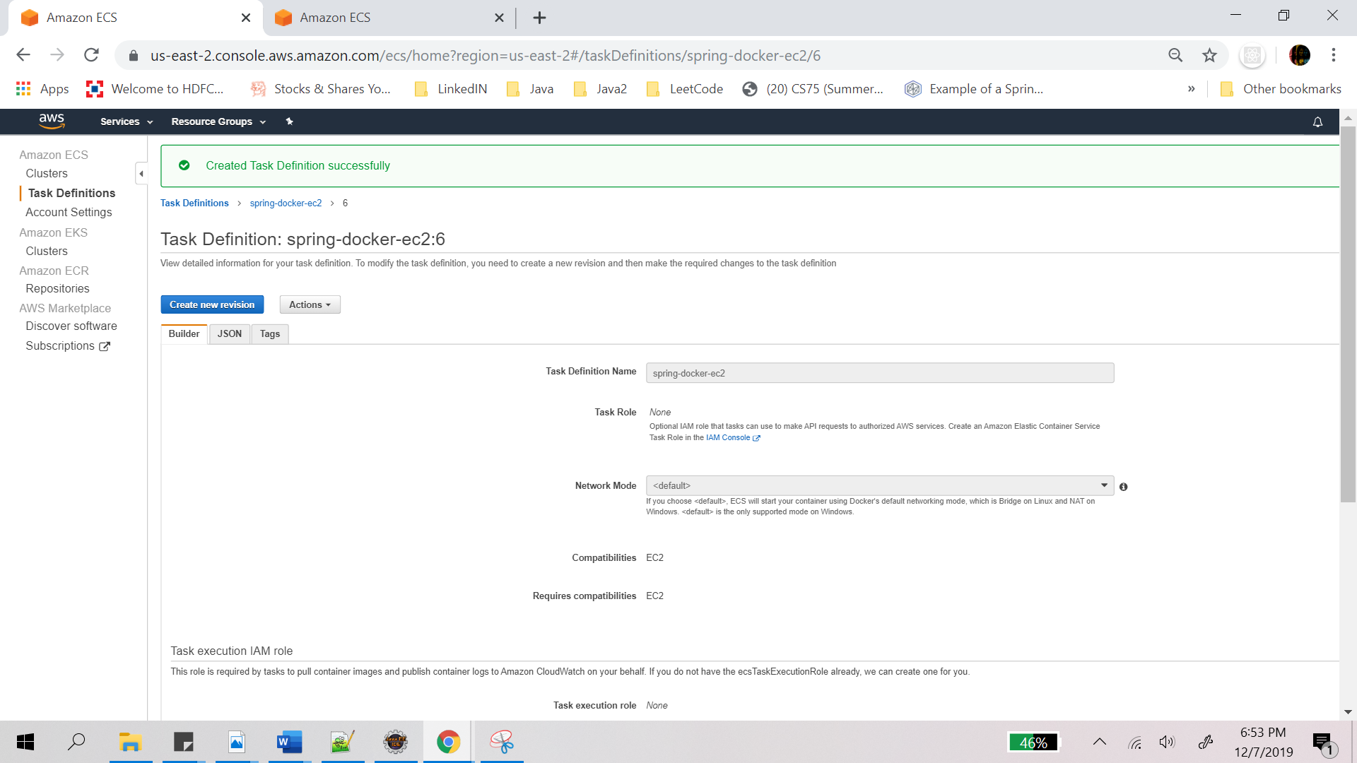

### **Create Cluster**

A cluster is required to run the task that we just created. So let’s go ahead and create a cluster.

1. Click on create cluster and the below page will open.
2. Select cluster template as “EC2 Linux + Networking”
3. Click on Next Step

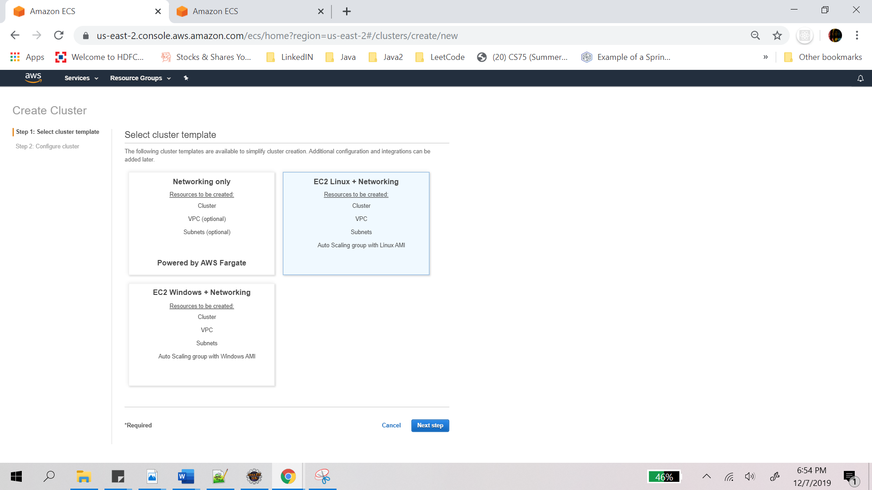

1. Next step is to Configure cluster:
   1. Provide cluster name.
   2. Click on create

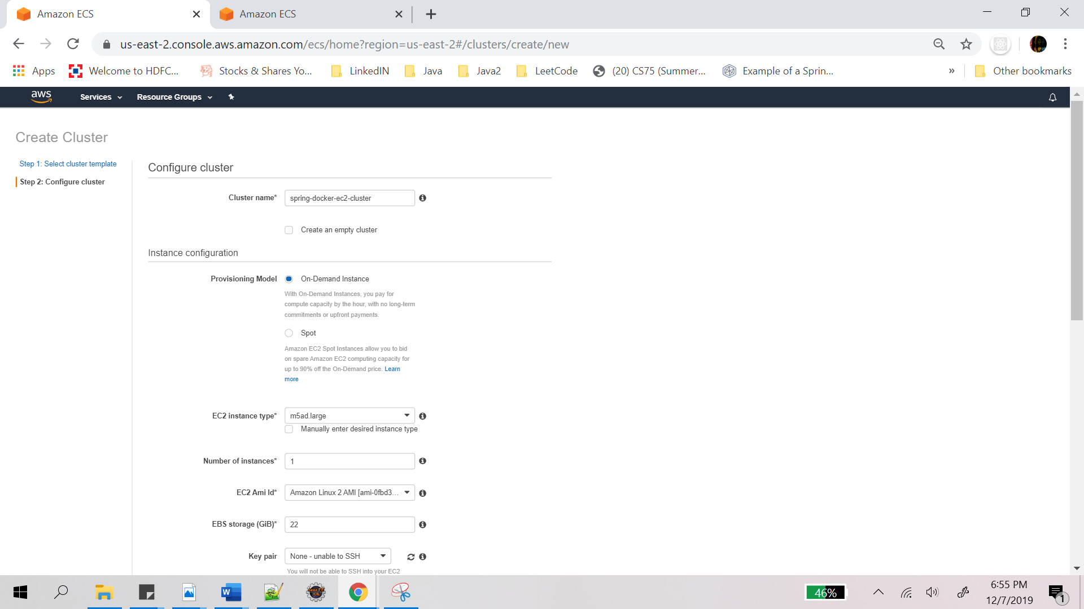

1. ECS cluster with EC2 instance is created.

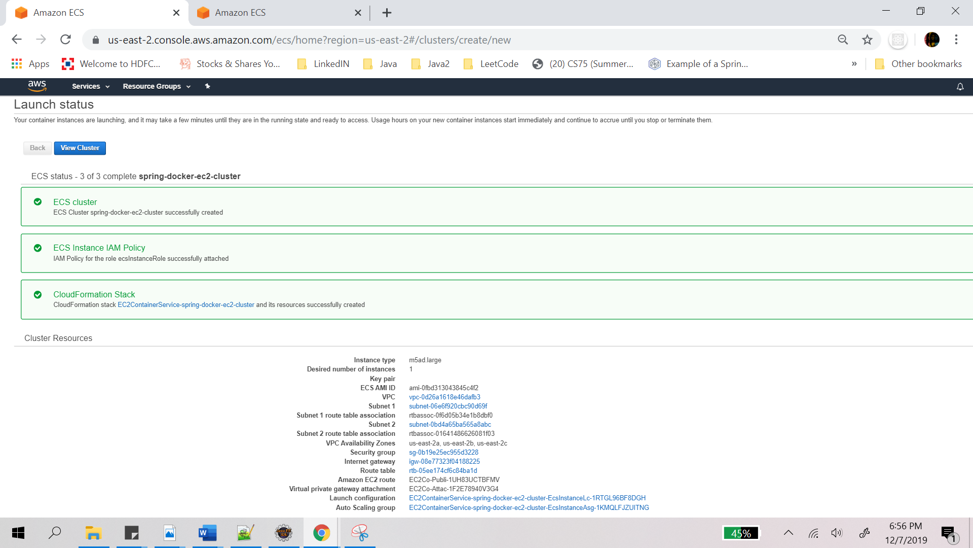

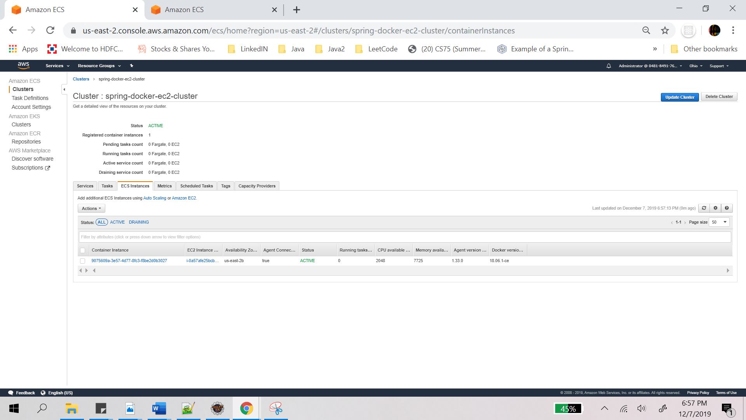

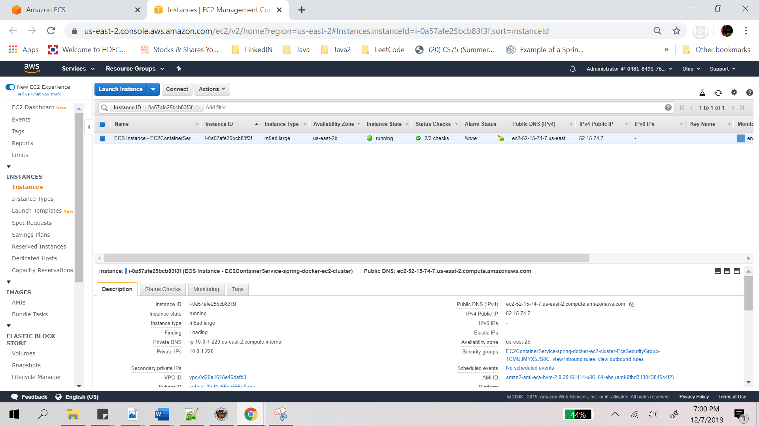

### **Run Task on the Cluster**

It’s time to run the task definition on the cluster. To do that go inside the cluster that was just created or simply click on view Cluster on the screen above.

1. Go to Tasks tab and click on Run new task, screen below will open.
2. Select Launch type as EC2
3. Provide task definition from the drop down
4. Cluster will be auto selected, if not select the cluster that was created previously from drop down.
5. Rest let it be whatever is provided

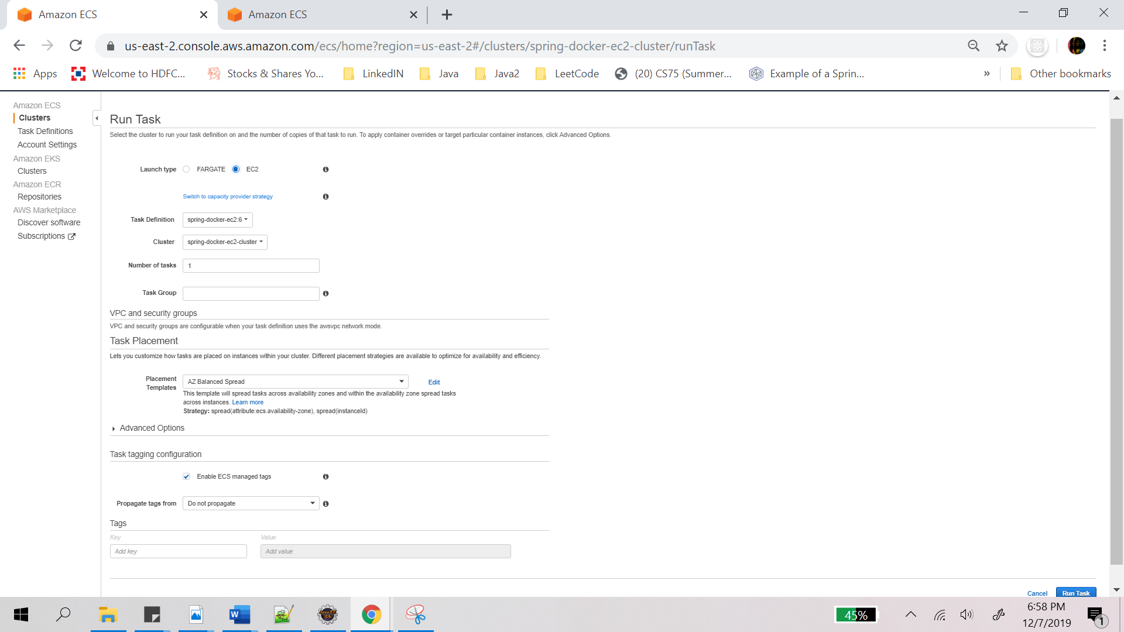

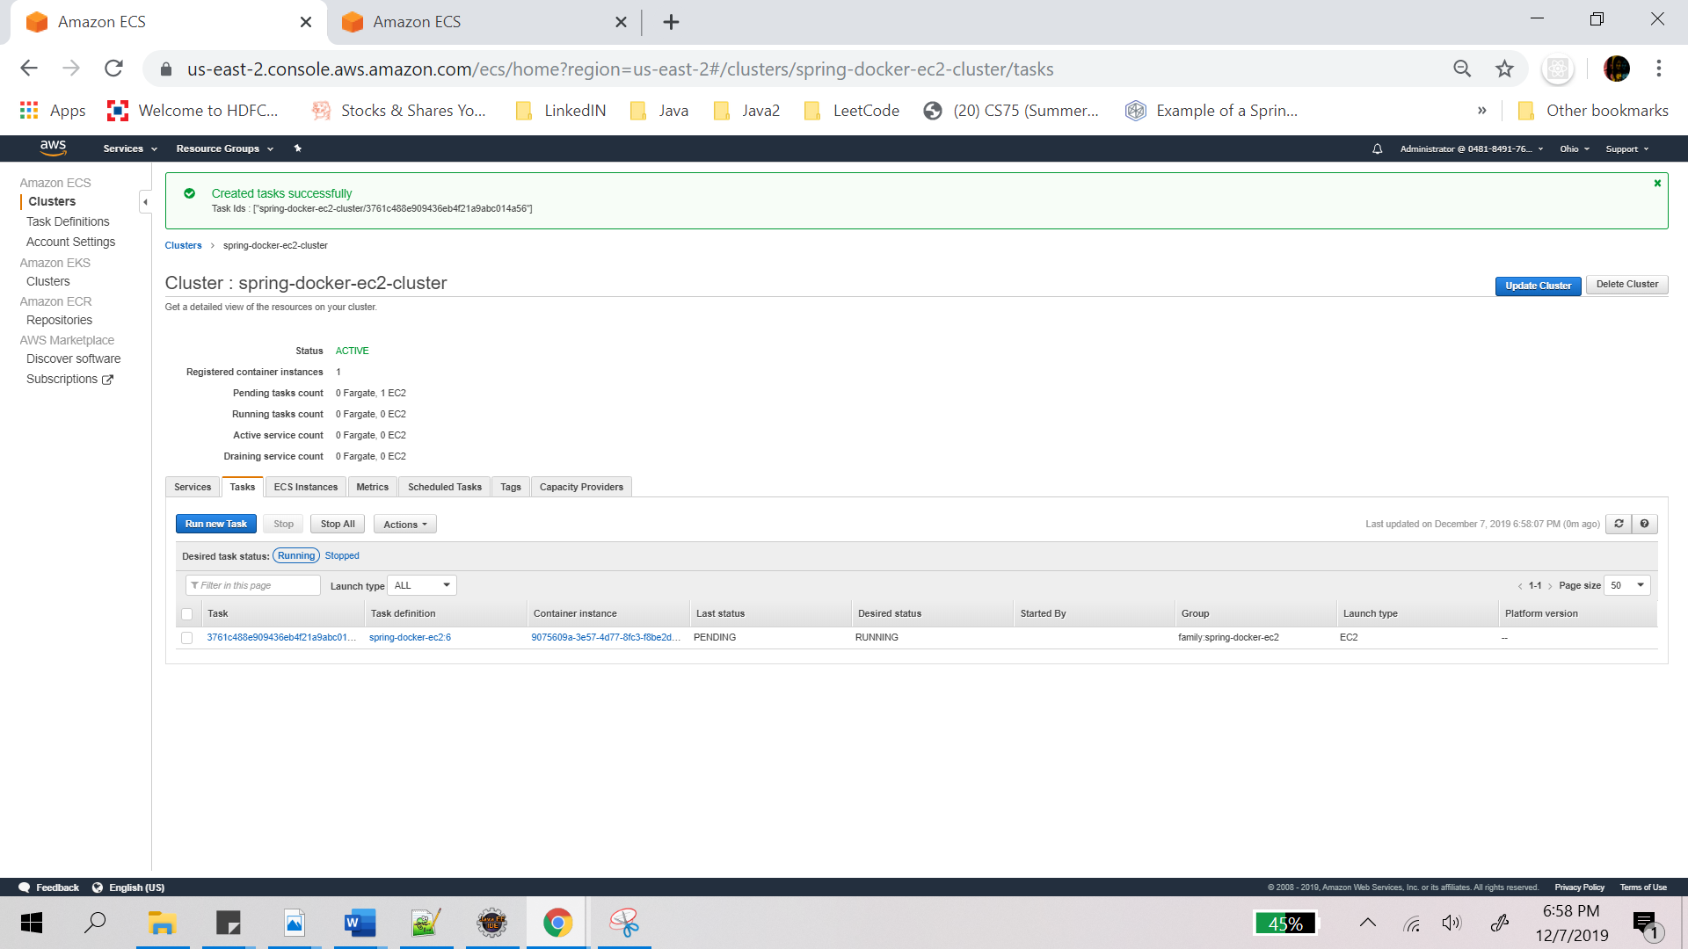

1. Task is now running

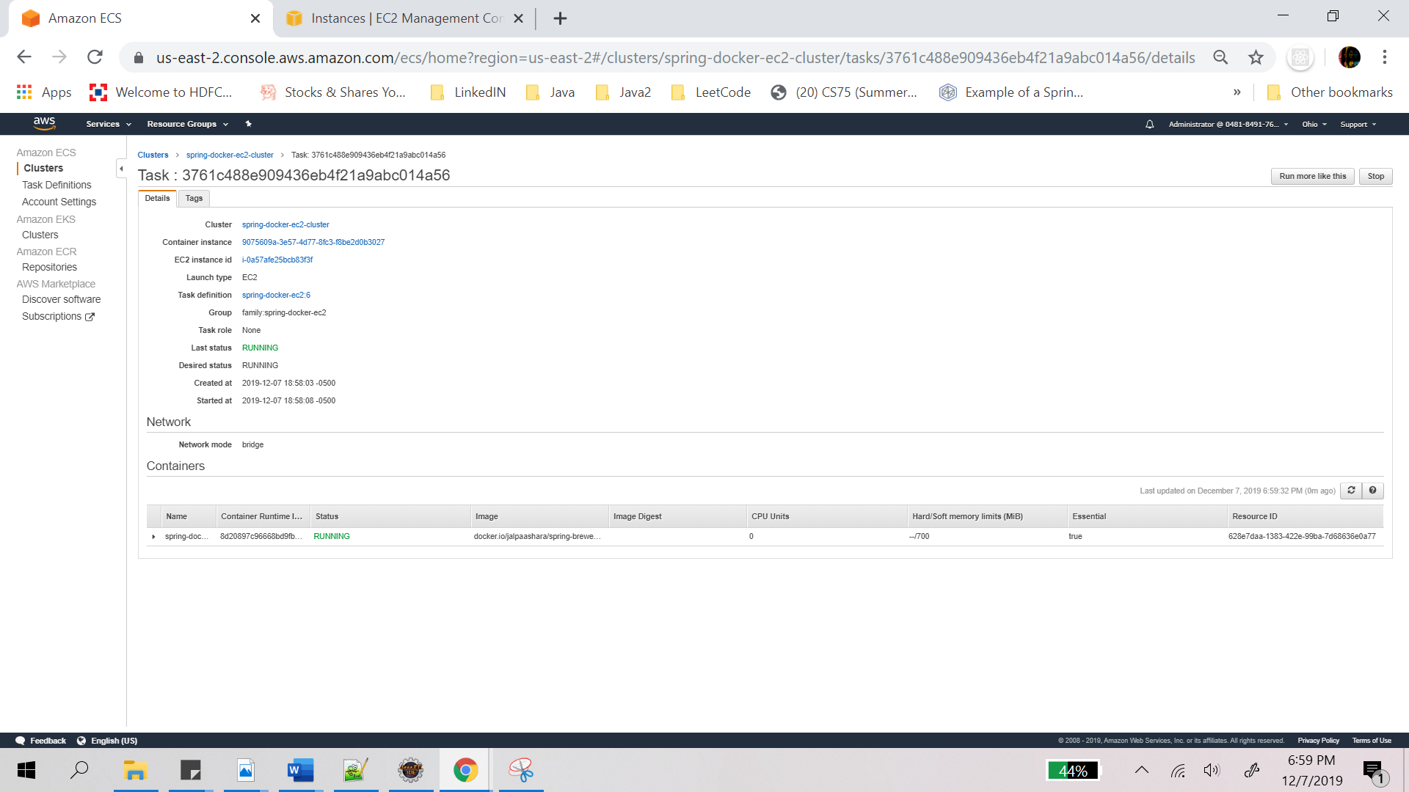

1. Go to a browser and provide the public_IP or Dns and you can see the JSON output.
2. <http://52.15.74.7> or <http://ec2-52-15-74-7.us-east-2.compute.amazonaws.com/>

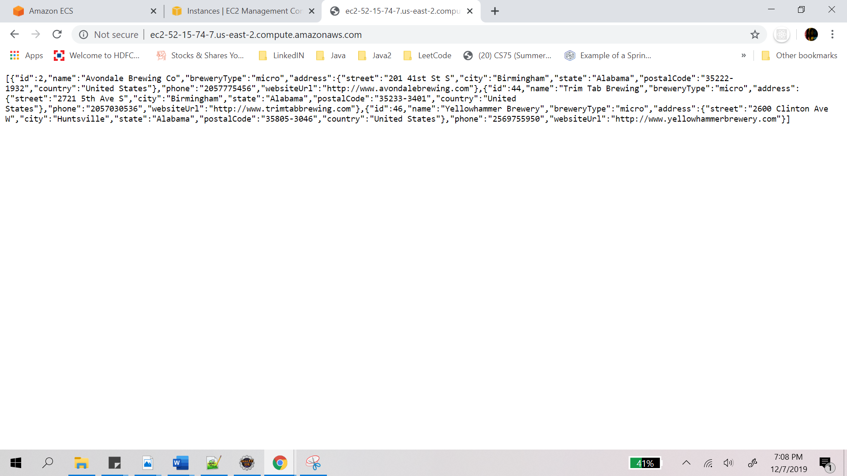

1. <http://52.15.74.7/44> or <http://ec2-52-15-74-7.us-east-2.compute.amazonaws.com/44>

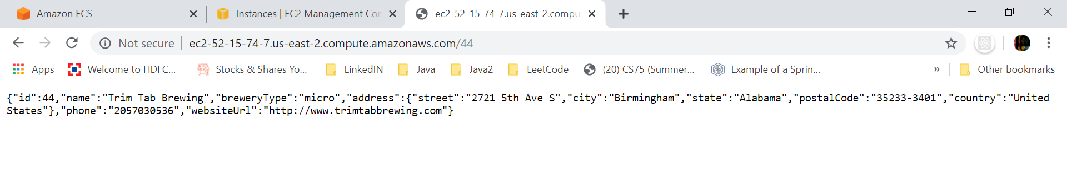

## **Create Repository on AWS ECR**

As mentioned earlier, Amazon Elastic Container Registry (ECR) is a fully-managed Docker container registry provided and fully managed by AWS. It hosts images in a highly available and scalable architecture, allowing reliably deploy containers for applications.

### **To tag a New image from Dockerfile and push it to Amazon ECR**

1. Go to services -> ECR -> Repositories -> Create Repository -> Provide repository name -> Create Repository

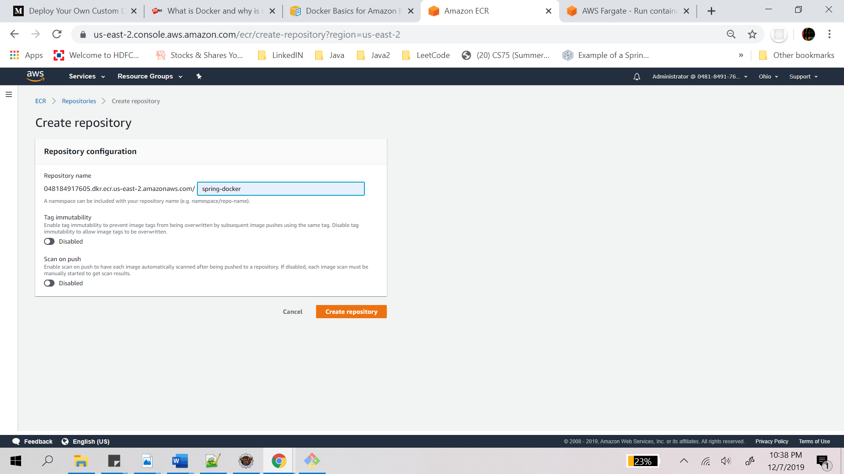

1. An empty repository will be created. Go inside the repository and click on View Push commands. Follow the commands as on the screen on AWS CLI

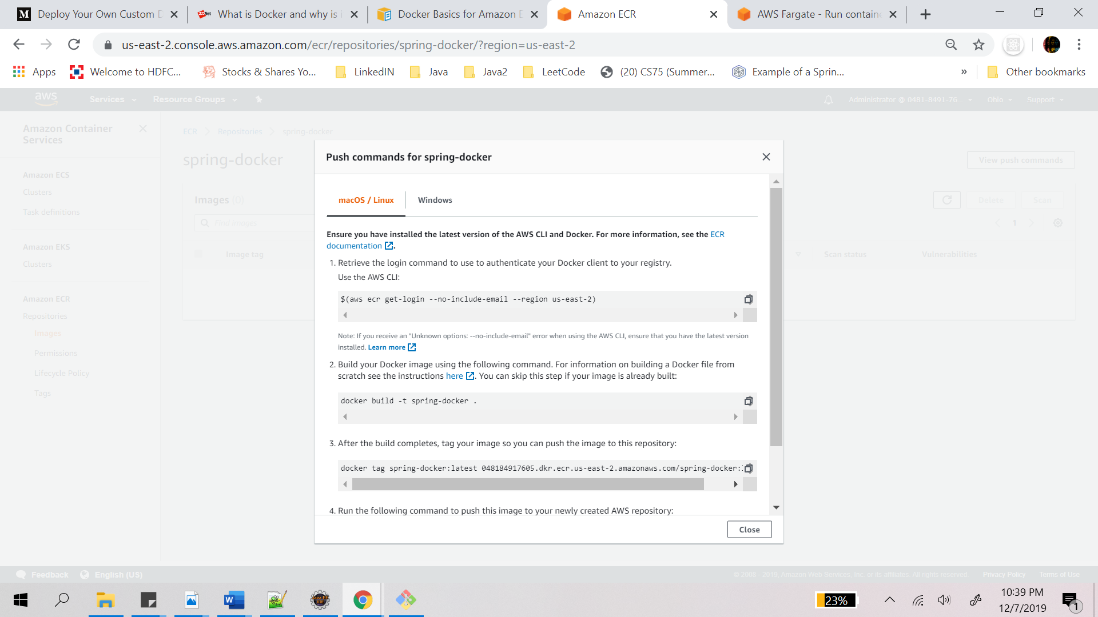

Screenshot shows logging into AWS, building and tagging docker image from dockerfile

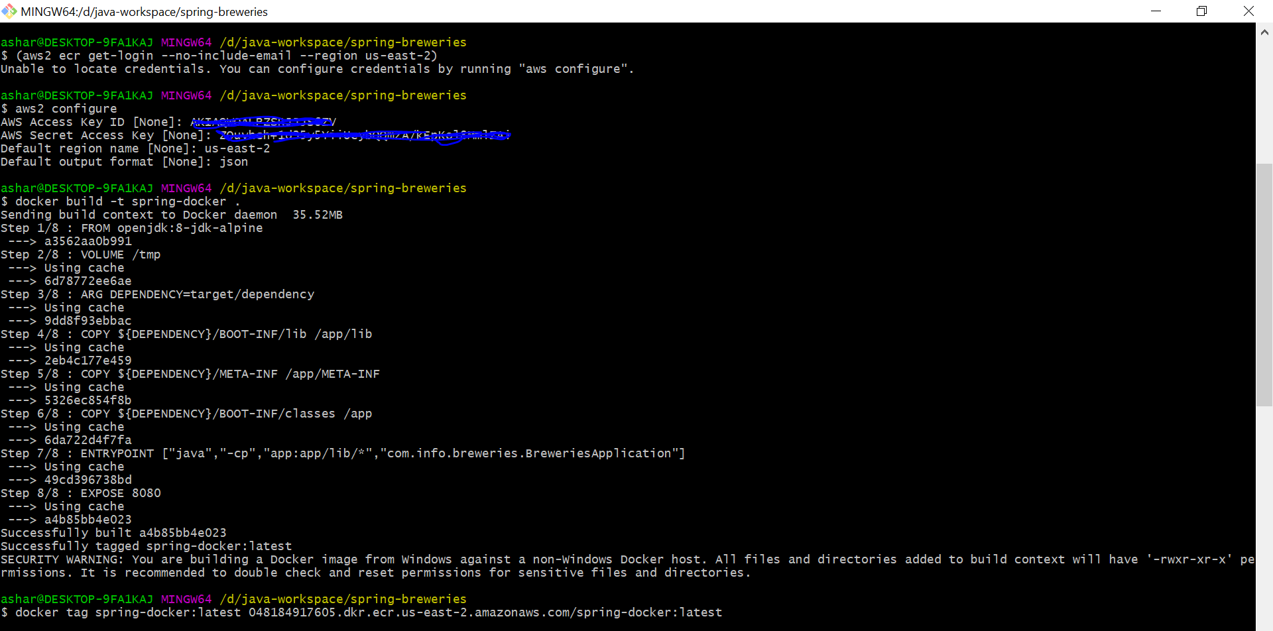

While pushing the docker image to ECR if you get an error saying “no basic auth credentials”, it means that the docker lookup for the key during push failed because docker will be looking for a server named “12345.dkr.ecr.us-east-w.amazonaws.com” not “12345.dkr.ecr.us-east-w.amazonaws.com”.

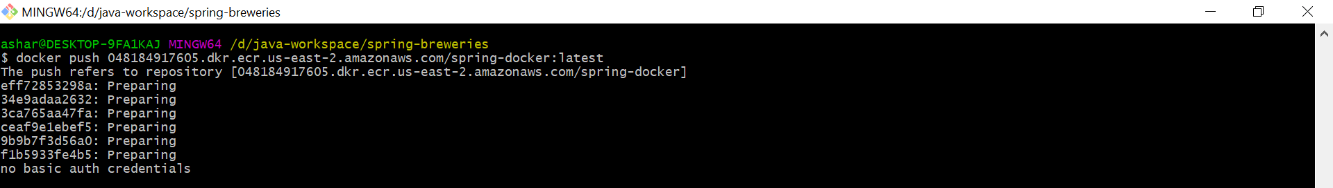

The solution therefore is to use the following wrapper to log in: eval $(aws ecr get-login | sed 's|https://||')

This command gets the login command, replaces https:// with `` (empty string) and evaluates the resulting command. This will store the received key under the correct server and can now be used it for docker push.

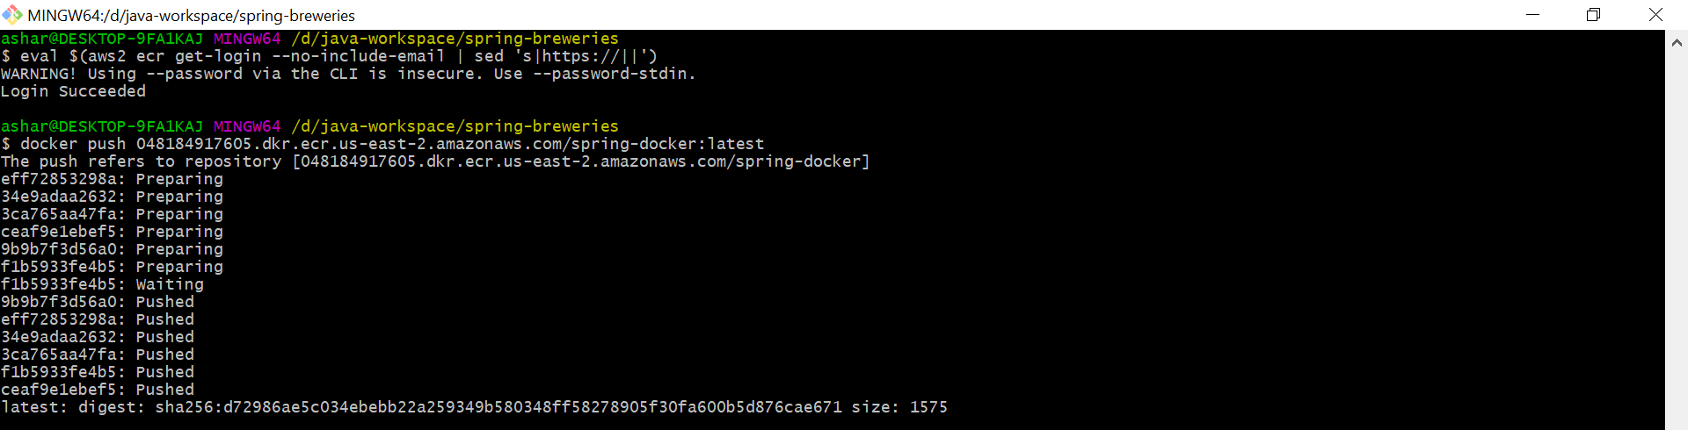

You can now see the image has been pushed to the repository on ECR

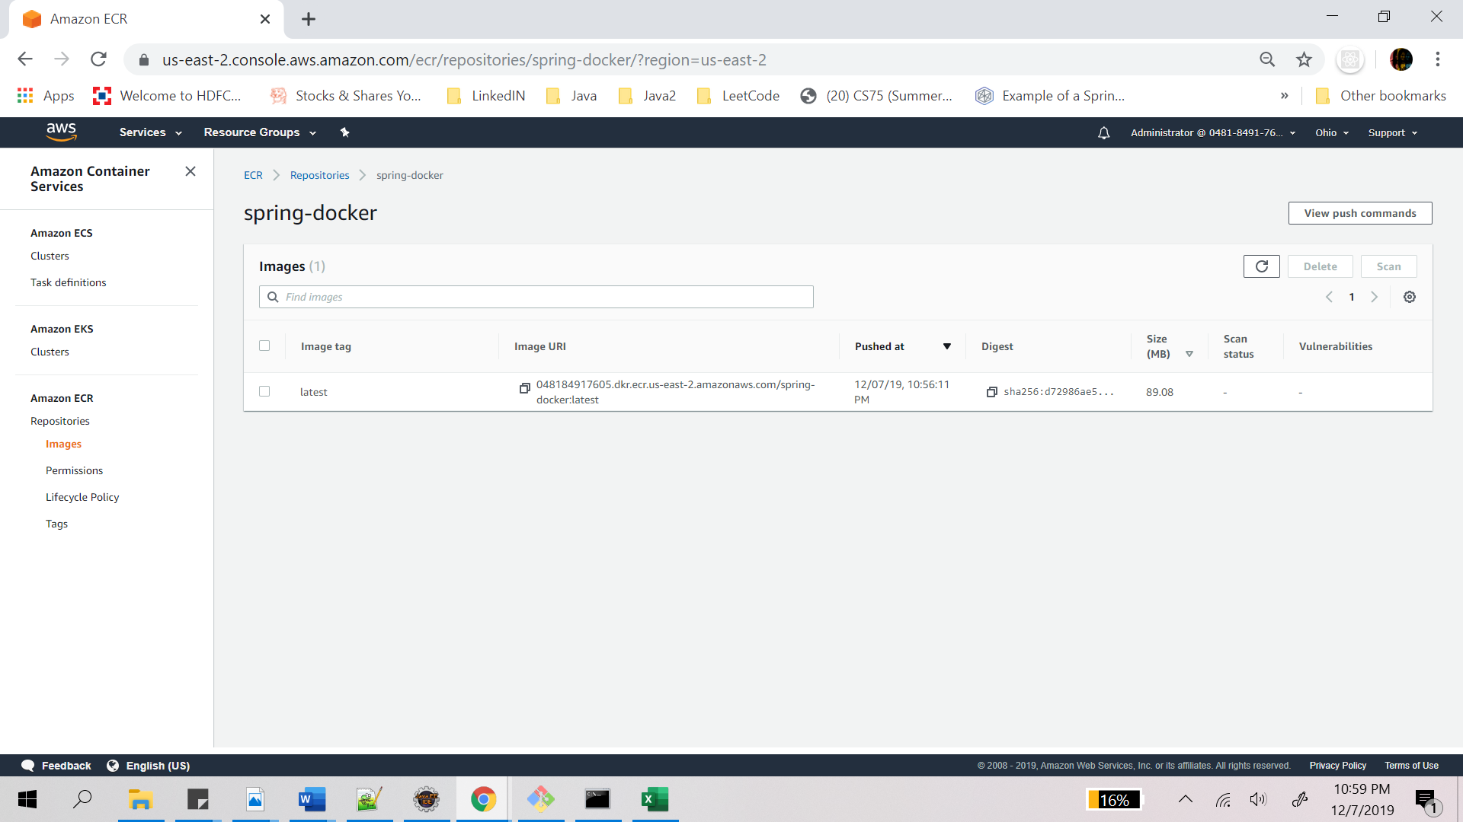

### **To tag an existing image from docker hub repository and push it to Amazon ECR**

1. Create an Amazon ECR repository to store breweries-repository image. Note the repositoryUri in the output. Command to do so is:

aws ecr create-repository –repository-name breweries-repository –region us-east-2

1. If you get an error to run aws configure, then run aws configure first and type the above mentioned command again as shown in the screenshots below

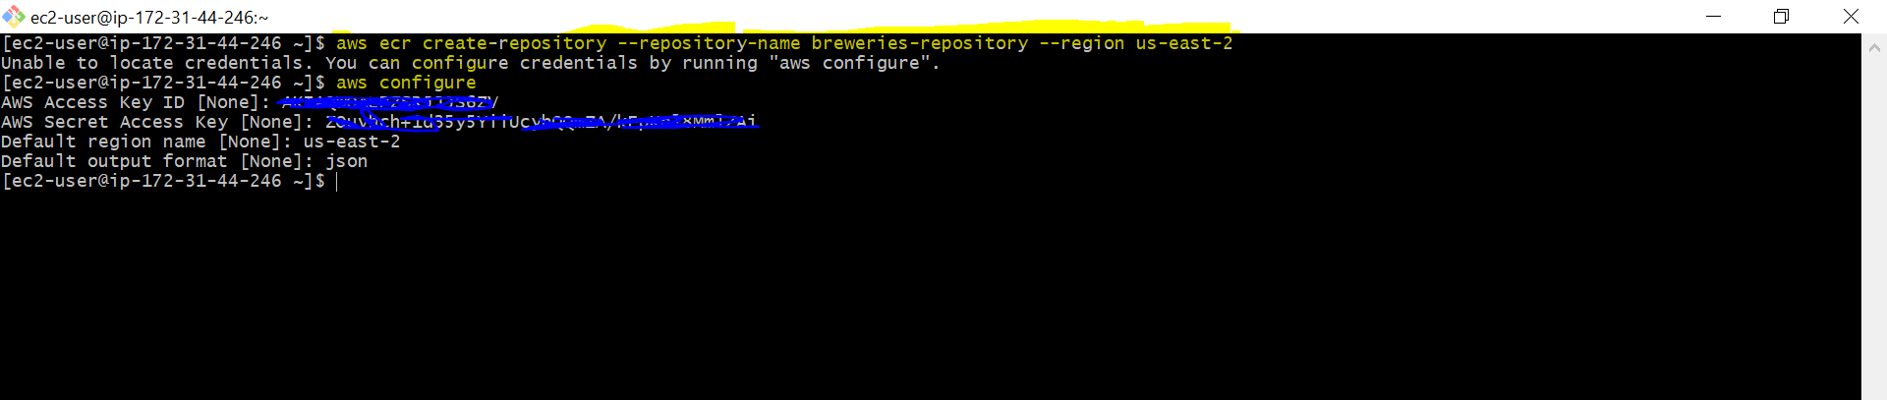

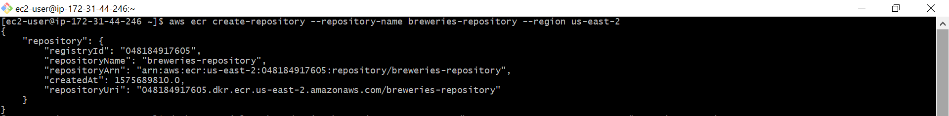

1. Tag the spring-breweries image with the repositoryUri value from the previous step.
2. Run the aws ecr get-login --no-include-email command to get the docker login authentication command string for your registry.

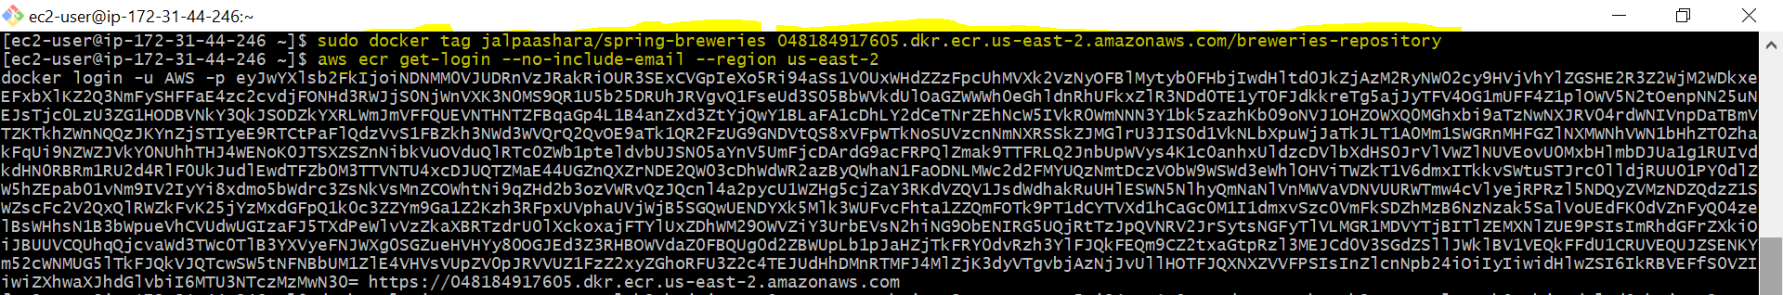

1. Run the docker login command that was returned in the previous step. This command provides an authorization token that is valid for 12 hours.

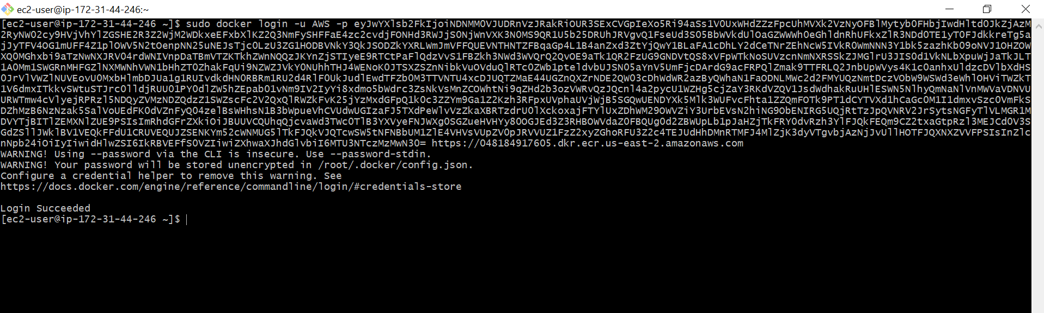

1. Push the image to Amazon ECR with the repositoryUri value from the earlier step.

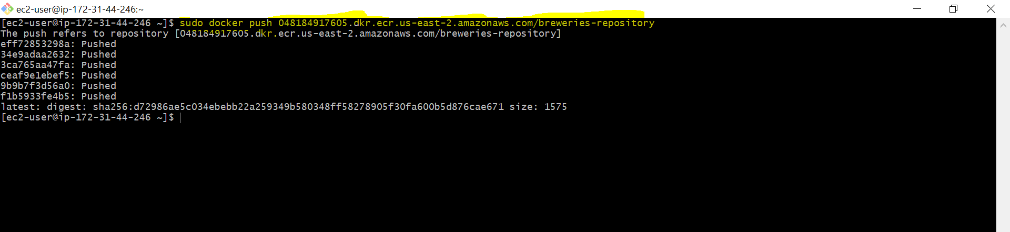

1. Check the ECR console.

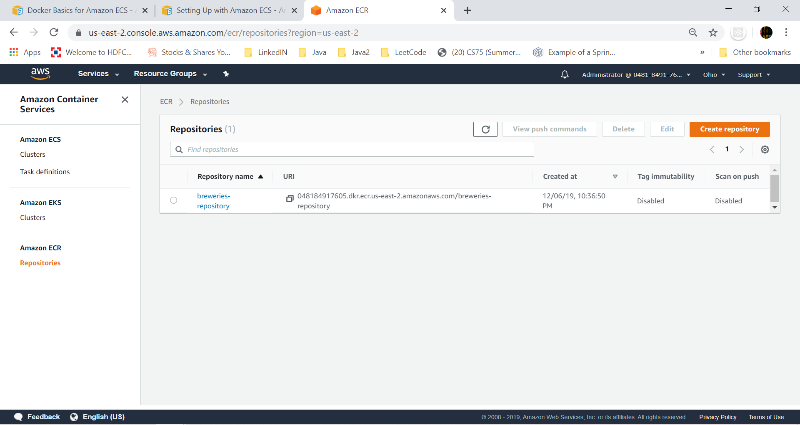

# **Conclusion**

Managing a large cluster of EC2 instances (i.e. scaling container) is generally harder and you need to make sure that all instances are patched, secured, and updated with the latest version of Docker in the right way. If you don’t want to get into instance management then Fargate is the best choice here. It will deploy clusters automatically by taking care of underlying infrastructure itself.